User

Manual

**Version 2.3**

|  |  |
| --- | --- |
| ***Corporate Office*** | ***Offshore Development Center*** |
| *1 Pickering Street*  *#06-03 Great Eastern Centre*  *Singapore 048659* | *Plot # 122 & 123, N.S.E.Z, Phase -2*  *NOIDA, UP 201 305*  *India*  *Tel: 91.11.91.2510483* |

|  |  |  |  |  |
| --- | --- | --- | --- | --- |
| **Author** | | | | |
| **Name** | **Role** | **Date of Preparation** | **Signature** | |
| Varun Gupta | Business Analyst | 30-Jan-2015 | Varun | |
| **Reviewer(s)** | | | | |
| **Name** | **Role** | **Date of Review** | **Signature** | |
| Pravesh Kumar | Manager Projects |  |  | |
|  |  |  |  | |
| **Approver** | | | | |
| **Name** | **Role** | **Date of Approval** | **Signature** | |
| ChengChoon Yip | VP Ebix Exchange  Asia |  |  | |
| **Document Path** | **Version Number** | **Date of Release** | | |
|  |  |  | | |
|  |  |  | | |
| **Revision History** | | | | |
| **Version Number** | **Date of Release** | **Section/ Page # Changed** | | **Details of Changes** |
|  |  |  | |  |
|  |  |  | |  |

|  |  |  |
| --- | --- | --- |
| **References** | | |
| **Document** | **Date Received** | **Author** |
|  |  |  |

Contents

1. Home Screen 12

2. Upload Main Menu 13

2.1 Search screen 14

2.2 Search Result screen 14

2.3 Upload Section 16

2.3.1 Field Validation 16

2.3.2 Dependencies 16

2.3.3 Message Handling 17

2.3.4 Outcome 17

2.4 Bus Captain Listing Screen 18

2.4.1 Add Screen 19

2.4.1.1 Screen Description 19

2.4.1.2 Field Validations 19

2.4.1.3 Dependencies 19

2.4.1.4 Outcome 19

2.4.1.5 Messages Handling 20

3. Type of Loss 20

3.1 Search Screen 20

3.1.1 Description 20

3.1.2 Field Validations 21

3.1.3 Dependencies 21

3.1.4 Outcome 21

3.1.5 Message Handling 21

3.2 Add Screen 22

3.2.1 Field Validations 22

3.2.2 Dependencies 22

3.2.3 Outcome 22

3.2.4 Message Handling 23

3.3 Edit Screen 24

3.3.1 Description 24

3.3.2 Dependencies 24

3.3.3 Outcome 24

3.4 View Screen 24

4. Main Class of Business 25

4.1 Search Screen 25

4.1.1 Description 25

4.1.2 Field Validations 25

4.1.3 Dependencies 25

4.1.4 Outcome 26

4.1.5 Message Handling 26

4.2 Add Screen 27

4.2.1 Description 27

4.2.2 Field Validations 27

4.2.3 Dependencies 28

4.2.4 Outcome 28

4.2.5 Message Handling 28

4.3 Edit Screen 29

5. Sub-Class 29

5.1 Search Screen 29

5.1.1 Description 29

5.1.2 Field Validations 29

5.1.3 Dependencies 29

5.1.4 Outcome 30

5.2 Add Screen 30

5.2.1 Description 30

5.2.2 Field Validations 31

5.2.3 Dependencies 31

5.2.4 Outcome 31

5.3 Edit Screen 31

6. Claim expense master 32

6.1 Search Screen 32

32

6.1.1 Field Validations 32

6.1.2 Outcome 32

6.2 Add Screen 33

6.2.1 Field Validations 34

6.2.2 Dependencies 34

6.2.3 Outcome 34

6.2.4 Message Handling 34

6.3 Edit Screen 35

7. Claim Close Reason Master 35

7.1 Search Screen 35

7.1.1 Field Validations 36

7.1.2 Dependencies 36

7.1.3 Outcome 36

7.2 Add Screen 37

7.2.1 Field Validations 37

7.2.2 Dependencies 37

7.2.3 Outcome 37

7.2.4 Message Handling 38

7.3 Edit Screen 38

8. Currency Master 38

8.1 Search Screen 38

8.1.1 Field Validations 39

8.1.2 Dependencies 39

8.1.3 Outcome 39

8.1.4 Message Handling 39

8.2 Add Screen 40

8.2.1 Field Validations 40

8.2.2 Dependencies 40

8.2.3 Outcome 40

8.2.4 Message Handling 41

8.3 Edit Screen 41

9. Exchange Rate Master 41

9.1 Search Screen 41

9.1.1 Field Validations 42

9.1.2 Dependencies 42

9.1.3 Outcome 42

9.2 Add Screen 43

9.2.1 Field Validations 43

9.2.2 Dependencies 43

9.2.3 Outcome 44

9.2.4 Message Handling 45

9.3 Edit Screen 45

10. User Admin 46

10.1 Entity Details 46

10.1.1 Search Screen 46

10.1.1.1 Field Validations 46

10.1.1.2 Dependencies 46

10.1.1.3 Outcome 47

10.1.1.4 Message Handling 47

10.1.2 Add Screen 47

10.1.2.1 Field Validations 47

10.1.2.2 Dependencies 48

10.1.2.3 Outcome 48

10.1.2.4 Message Handling 48

10.1.3 Edit Screen 49

10.2 User Group 49

10.2.1 Search Screen 49

10.2.1.1 Field Validations 49

10.2.1.2 Dependencies 50

10.2.1.3 Outcome 50

10.2.2 Add Screen 51

10.2.2.1 Field Validations 52

10.2.2.2 Dependencies 52

10.2.2.3 Outcome 52

10.2.2.4 Message Handling 52

10.2.3 Edit Screen 54

10.2.4 Select Permission List Screen 54

10.2.4.1 Field Validations 55

10.2.4.2 Outcome 56

10.3 User Screen 57

10.3.1 Search Screen 57

10.3.1.1 Field Validations 57

10.3.1.2 Dependencies 58

10.3.1.3 Outcome 58

10.3.2 Add Screen 59

10.3.2.1 Field Validations 59

10.3.2.2 Dependencies 60

10.3.2.3 Outcome 60

10.3.2.4 Message Handling 61

10.3.3. Edit Screen 62

10.3.4 Organization Access Tab 62

10.3.4.1 Field Validations 62

10.3.4.2 Dependencies 62

10.3.4.3 Outcome 63

10.3.5 FAL Access to User 63

10.3.5.1 Description 63

10.3.5.2 Field Validations 63

10.3.5.3 Dependencies 63

10.3.5.4 Outcome 63

10.3.5.5 Message Handling 63

10.4 Department master 64

10.4.1 Search Screen 64

10.4.1.1 Field Validations 64

10.4.1.2 Dependencies 64

10.4.1.3 Outcome 64

10.4.2 Add Screen 65

10.4.2.1 Field Validations 65

10.4.2.2 Dependencies 65

10.4.2.3 Outcome 65

10.4.3 Edit Screen 65

10.5 Password Setup 66

10.5.1 Main Screen 66

10.5.1.1 Field Validations 67

10.5.1.2 Dependencies 67

10.5.1.3 Outcome 67

10.5.1.4 Message Handling 67

10.6 Released Locked User 68

10.7 Country For User Access 68

11. Country Master 69

11.1 Search Screen 69

11.1.1 Field Validations 69

11.1.2 Dependencies 69

11.1.3 Outcome 70

11.2 Add Screen 70

70

11.2.1 Field Validations 70

11.2.2 Dependencies 70

11.2.3 Outcome 70

11.3 Edit Screen 71

12. Vehicle Class 71

12.1 Search Screen 71

12.1.1 Field Validations 71

12.2 Add Screen 72

12.2.1 Field Validations 72

13. Vehicle Make 72

13.1 Search Screen 72

13.1.1 Field Validations 73

13.1.2 Dependencies 73

13.2 Add Screen 73

13.2.1 Field Validations 73

13.3 Edit Screen 74

14. Vehicle Model 75

14.1 Search Screen 75

14.1.1 Field Validations 75

14.2 Add Screen 76

14.2.1 Field Validations 76

14.2.2 Dependencies 77

14.3 Edit Screen 77

15. Insurance Policy 77

15.1 Search Screen 77

15.1.1 Field Validations 78

15.1.2 Dependencies 78

15.1.3 Outcome 78

15.2 Add Screen 78

15.2.1 Field Validations 79

15.2.2 Dependencies 79

15.3 Edit Screen 80

16. GST Setting 80

16.1 Search Screen 80

16.1.1 Field Validations 80

16.1.2 Dependencies 80

16.1.3 Outcome 81

16.1.4 Message Handling 81

16.2 Add Screen 81

16.2.1 Field Validations 81

16.2.2 Dependencies 81

16.2.3 Outcome 81

16.2.4 Message Handling 81

17. Organization 81

17.1 Search Screen 82

17.1.1 Outcome 82

17.2 Add Screen 83

17.2.1 Description 83

17.2.2 Field Validations 84

17.2.3 Dependencies 85

17.2.4 Outcome 85

17.2.5 Message Handling 85

17.3 Edit Screen 85

18. Claim Officer Duty 85

18.1 Search Screen 85

18.1.1 Description 86

18.1.2 Field Validations 86

18.1.3 Dependencies 86

18.1.4 Outcome 86

18.1.5 Message Handling 86

18.2 Add Screen 86

18.2.1 Description 86

18.2.2 Field Validations 86

18.2.3 Dependencies 86

18.2.4 Outcome 86

18.2.5 Message Handling 86

18.3 Edit Screen 86

18.3.1 Description 86

18.3.2 Field Validations 86

18.3.3 Dependencies 86

18.3.4 Outcome 86

18.3.5 Message Handling 86

19. LOU Rate 86

19.1 Search Screen 87

19.1.1 Description 87

19.1.2 Field Validations 87

19.1.3 Dependencies 87

19.1.4 Outcome 87

19.1.5 Message Handling 87

19.2 Add Screen 87

19.2.1 Description 87

19.2.2 Field Validations 87

19.2.3 Dependencies 87

19.2.4 Outcome 87

19.2.5 Message Handling 87

19.3 Edit Screen 87

19.3.1 Description 87

19.3.2 Field Validations 87

19.3.3 Dependencies 87

19.3.4 Outcome 87

19.3.5 Message Handling 87

20. Service Provider Master 88

20.1 Insurer Master 88

20.2 Search Screen 88

20.2.1.1 Description 88

20.2.1.2 Field Validations 88

20.2.1.3 Dependencies 88

20.2.1.4 Outcome 88

20.2.1.5 Message Handling 88

20.3 Add Screen 88

20.3.1.1 Description 89

20.3.1.2 Field Validations 89

20.3.1.3 Dependencies 89

20.3.1.4 Outcome 89

20.3.1.5 Message Handling 89

20.4 Edit Screen 89

20.4.1.1 Description 90

20.4.1.2 Field Validations 90

20.4.1.3 Dependencies 90

20.4.1.4 Outcome 90

20.4.1.5 Message Handling 90

20.5 Surveyor Master 90

20.6 Search Screen 90

20.6.1.1 Description 90

20.6.1.2 Field Validations 90

20.6.1.3 Dependencies 90

20.6.1.4 Outcome 90

20.6.1.5 Message Handling 90

20.7 Add Screen 90

20.7.1.1 Description 90

20.7.1.2 Field Validations 90

20.7.1.3 Dependencies 90

20.7.1.4 Outcome 90

20.7.1.5 Message Handling 90

20.7.2 Edit Screen 91

20.7.2.1 Description 91

20.7.2.2 Field Validations 91

20.7.2.3 Dependencies 91

20.7.2.4 Outcome 91

20.7.2.5 Message Handling 91

20.8 Lawyer Master Screen 91

20.9 Search Screen 91

20.9.1.1 Description 91

20.9.1.2 Field Validations 92

20.9.1.3 Dependencies 92

20.9.1.4 Outcome 92

20.9.1.5 Message Handling 92

20.10 Add Screen 92

20.10.1.1 Description 92

20.10.1.2 Field Validations 92

20.10.1.3 Dependencies 92

20.10.1.4 Outcome 92

20.10.1.5 Message Handling 92

20.11 Edit Screen 93

20.11.1.1 Description 93

20.11.1.2 Field Validations 93

20.11.1.3 Dependencies 93

20.11.1.4 Outcome 93

20.11.1.5 Message Handling 93

20.12 Workshop/Depot Master 94

20.13 Search Screen 94

20.13.1.1 Description 94

20.13.1.2 Field Validations 94

20.13.1.3 Dependencies 94

20.13.1.4 Outcome 94

20.13.1.5 Message Handling 94

20.14 Add Screen 94

20.14.1.1 Description 95

20.14.1.2 Field Validations 95

20.14.1.3 Dependencies 95

20.14.1.4 Outcome 95

20.14.1.5 Message Handling 95

20.15 Edit Screen 96

20.15.1.1 Description 96

20.15.1.2 Field Validations 96

20.15.1.3 Dependencies 96

20.15.1.4 Outcome 96

20.15.1.5 Message Handling 96

20.16 Hospital Master 96

20.17 Search Screen 96

20.17.1.1 Description 96

20.17.1.2 Field Validations 96

20.17.1.3 Dependencies 96

20.17.1.4 Outcome 96

20.17.1.5 Message Handling 96

20.18 Add Screen 97

20.18.1.1 Description 97

20.18.1.2 Field Validations 98

20.18.1.3 Dependencies 98

20.18.1.4 Outcome 98

20.18.1.5 Message Handling 98

20.19 Edit Screen 98

20.19.1.1 Description 98

20.19.1.2 Field Validations 98

20.19.1.3 Dependencies 98

20.19.1.4 Outcome 98

20.19.1.5 Message Handling 98

20.20 Adjuster Master 99

20.21 Search Screen 99

20.21.1.1 Description 99

20.21.1.2 Field Validations 99

20.21.1.3 Dependencies 99

20.21.1.4 Outcome 99

20.21.1.5 Message Handling 99

20.22 Add Screen 99

20.22.1.1 Description 100

20.22.1.2 Field Validations 100

20.22.1.3 Dependencies 100

20.22.1.4 Outcome 100

20.22.1.5 Message Handling 100

20.23 Edit Screen 101

20.23.1.1 Description 101

20.23.1.2 Field Validations 101

20.23.1.3 Dependencies 101

20.23.1.4 Outcome 101

20.23.1.5 Message Handling 101

21. Interchange Master Screen 101

21.1 Search Screen 101

21.1.1 Description 101

21.1.2 Field Validations 101

21.1.3 Dependencies 101

21.1.4 Outcome 101

21.1.5 Message Handling 101

21.2 Add Screen 101

21.2.1 Description 102

21.2.2 Field Validations 102

21.2.3 Dependencies 102

21.2.4 Outcome 102

21.2.5 Message Handling 102

21.3 Edit Screen 102

21.3.1 Description 102

21.3.2 Field Validations 102

21.3.3 Dependencies 102

21.3.4 Outcome 102

21.3.5 Message Handling 102

22. Deductible Master 102

22.1 Search Screen 102

22.1.1 Description 102

22.1.2 Field Validations 103

22.1.3 Dependencies 103

22.1.4 Outcome 103

22.1.5 Message Handling 103

22.2 Add Screen 103

22.2.1 Description 103

22.2.2 Field Validations 103

22.2.3 Dependencies 103

22.2.4 Outcome 103

22.2.5 Message Handling 103

22.3 Edit Screen 104

22.3.1 Description 104

22.3.2 Field Validations 104

22.3.3 Dependencies 104

22.3.4 Outcome 104

22.3.5 Message Handling 104

# Home Screen

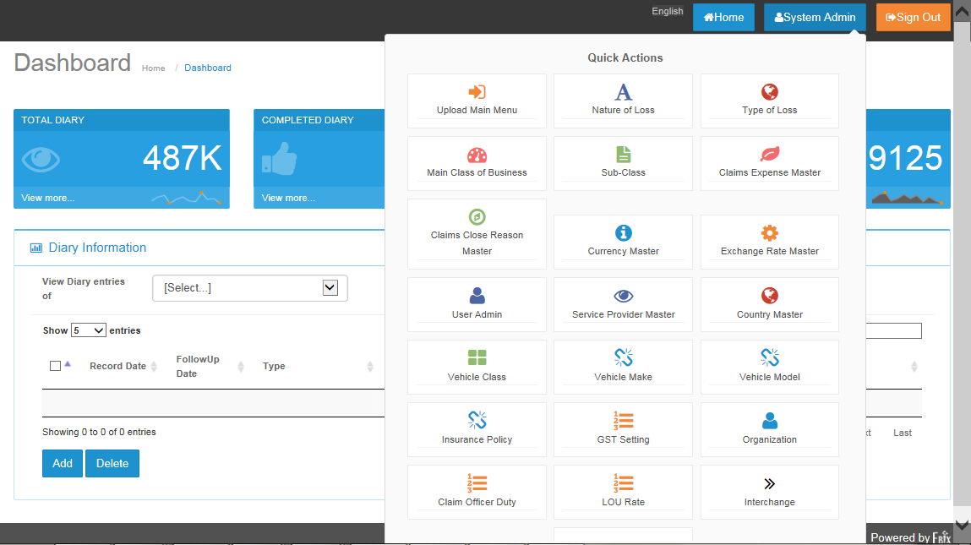

* Click on  to see Master list.

# Upload Main Menu

## Search screen



* Vehicle listing upload screen will appear by default.
* User can search either filling values on any of the text box
* After click on Search button user will get results.

## Search Result screen

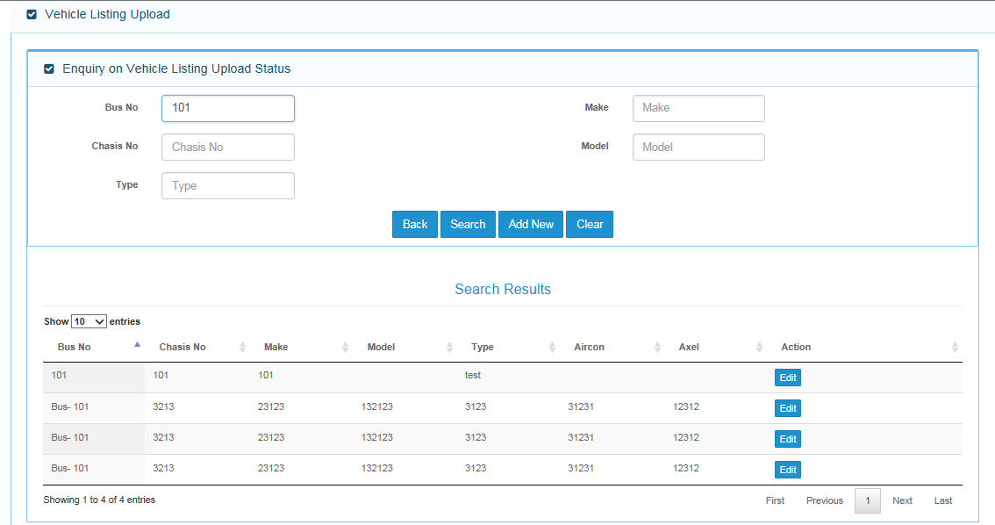

* After Click on edit button , Below screen will appear for editing any existing record.

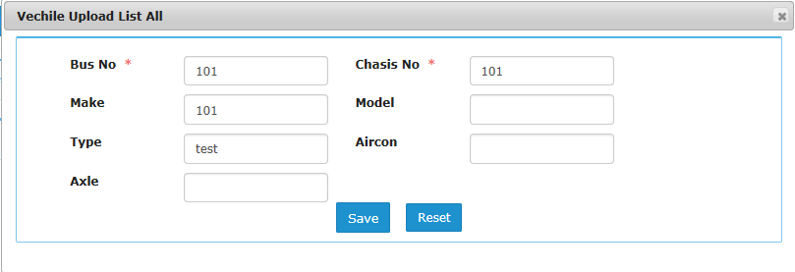

* User can enter new values and click on save button to edit any record.
* Field Validation :

|  |  |  |
| --- | --- | --- |
| **S.No.** | **Field Name** | **Validation** |
| 1. | Bus No. | Alphanumeric Value, Infinite Length |
| 2. | Make | Alphanumeric Value, Infinite Length |
| 3. | Chasis No. | Alphanumeric Value, Infinite Length |
| 4. | Model | Alphanumeric Value, Infinite Length |
| 5. | Type | Alphanumeric Value, Infinite Length |
| 6. | Aircon | Alphanumeric Value, Infinite Length |
| 7. | Axle | Alphanumeric Value, Infinite Length |

## Upload Section

* Below Search result screen, Upload section screen is located at the bottom of screen.

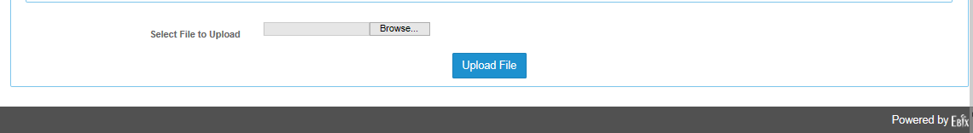

* Click on Browse button to search file to be uploaded.
* Click on Upload File button to start upload process.

### Field Validation

* Excel file needs to be inserted
* File must have 6 columns
* File with blank records , will not be allowed for insertion
* Duplicate file cannot be uploaded.

### Dependencies

* No Dependencies on file upload operation

### Message Handling

* If user does not select any file and click on Upload File. The below error message will appear.



### Outcome

* Record will be saved in database and shown in search result grid as following.

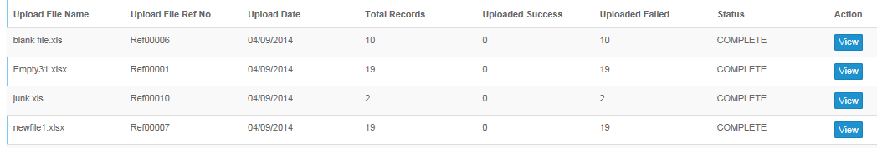

## Bus Captain Listing Screen

* Click search button to search existing record.
* Click Add new button to add bus captain record.
* Click Edit button to edit selected record.
* Click view button to view selected record.

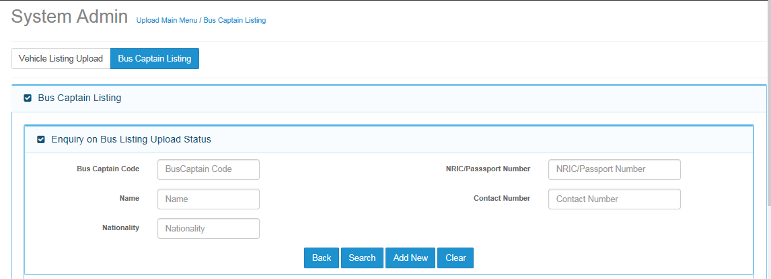

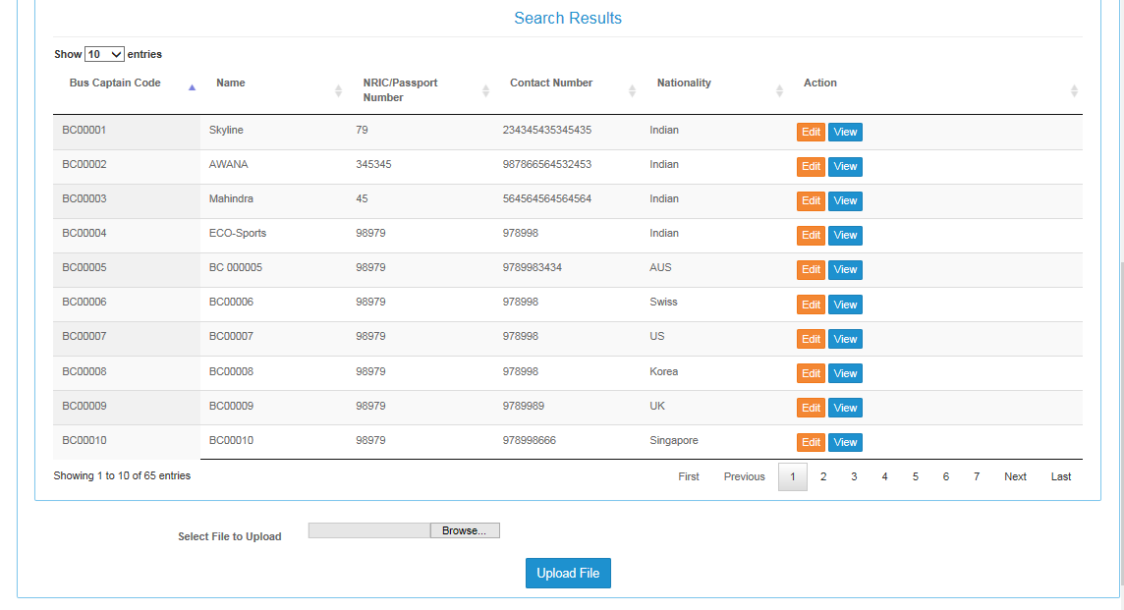

### Add Screen

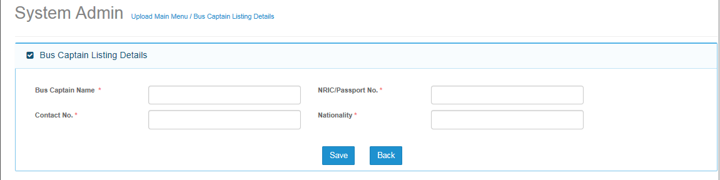

#### Screen Description

* Add screen will be used to add bus captain information.

#### Field Validations

|  |  |  |
| --- | --- | --- |
| **S.No.** | **Field Name** | **Validation** |
| 1. | Bus Captain name: | 150 length |
| 2. | NRIC/Passport No. | 40 length |
| 3. | Contact no. | 15 length |
| 4. | Nationality | 80 length |

#### Dependencies

* Not Applicable

#### Outcome

* Record will be saved in database.
* Record will appear in search screen.

#### Messages Handling

* Below error message will appear, if user not enters bus captain code and direct click on save button.



# Type of Loss

* Please mention description of business use of type of loss.

## Search Screen

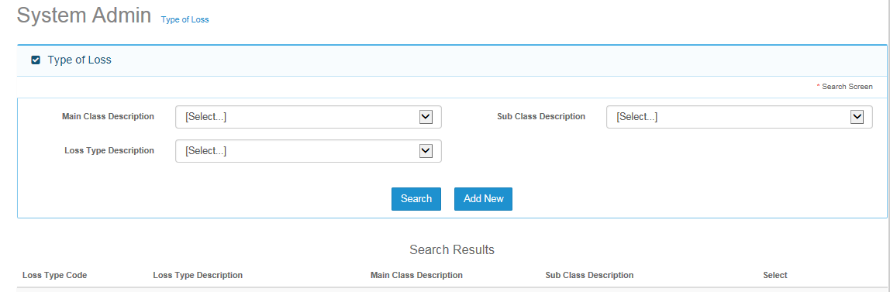

### Description

* Search screen will be first screen, when user clicks on type of loss menu.
* User can search record by entering one of three given fields.
* User need to first fill search criteria and then click on search button.
* Record will be displayed in search result section as per value filled in the search criteria.

### Field Validations

|  |  |  |
| --- | --- | --- |
| **S.No.** | **Field Name** | **Validation** |
| 1. | Main Class Description | Value from Drop down list |
| 2. | Sub Class Description | Value from Drop down list |
| 3. | LOSS Type description | Value from Drop down list |

### Dependencies

* No Dependencies of search screen with any other screen.

### Outcome



* Record will be displayed after clicking on search screen.

### Message Handling

* All fields in search criteria are drop down list, so there will be no error message while selecting any value.

## Add Screen

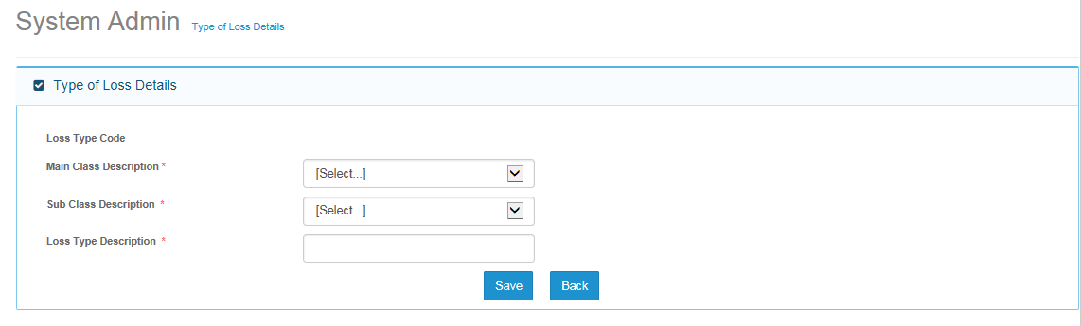

### Field Validations

|  |  |  |
| --- | --- | --- |
| **S.No.** | **Field Name** | **Validation** |
| 1. | Main Class Description | Value from Drop down list |
| 2. | Sub Class Description | Value from Drop down list |
| 3. | LOSS Type description | Alphanumeric- 30 character |

### Dependencies

* Values needs to be saved in Main Class master.
* Values needs to be saved in Sub class master.

### Outcome

* Record will be saved in database.
* Saved record will be displayed in search result section.

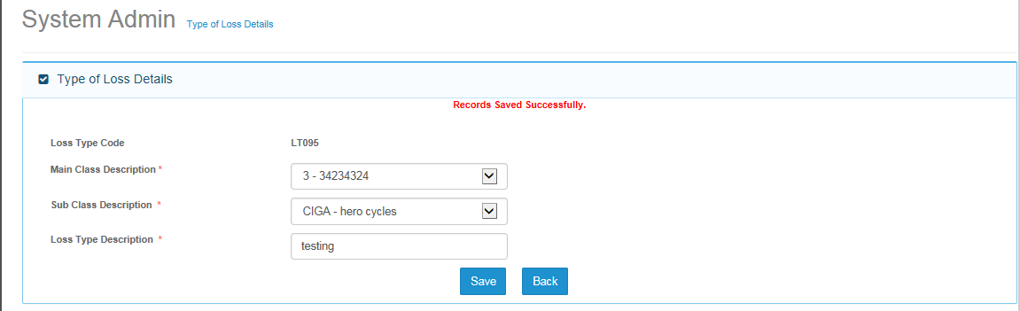

### Message Handling

* Validation message will appear, if user will click on save button without entering/selecting any value.

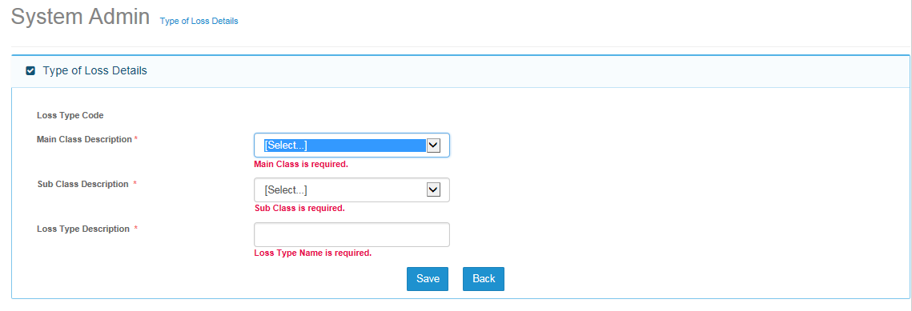

## Edit Screen

### Description

* To edit any existing record, user can search a particular record and then click on edit button to make changes in the record.

### Dependencies

* Records must be saved in the database, and then only it can be edited.

### Outcome

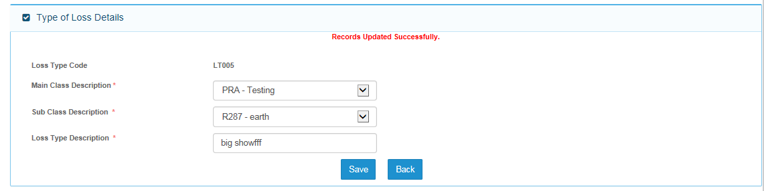

## View Screen

Note:

On View Screen, Save button will be hide and user will not be able to save any record.

# Main Class of Business

## Search Screen

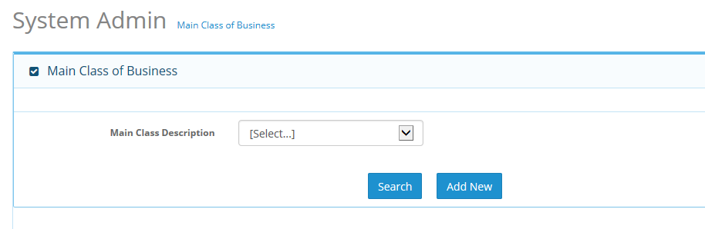

### Description

* Based on Main Class description field, records can be searched.

### Field Validations

|  |  |  |
| --- | --- | --- |
| **S.No.** | **Field Name** | **Validation** |
| 1. | Main Class Description | Record will come in drop down list. |

### Dependencies

* Main Class Description is a drop down list, only existing record will be displayed in the drop down list.

### Outcome

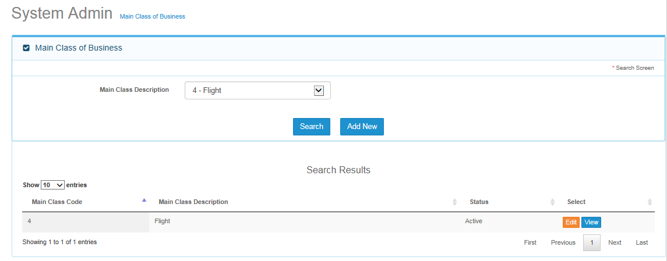

* Record will be displayed based on search criteria.

### Message Handling

* Not Applicable.

## Add Screen

### Description

* Please Add functional information of main class menu.

### Field Validations

|  |  |  |
| --- | --- | --- |
| **S.No.** | **Field Name** | **Validation** |
| 1. | Main Class Code | 3 |
| 2. | Main Class Description | 50 Character |
| 3. | Status | Not Applicable |

### Dependencies

* Status Dropdown List should have values “Active and Inactive”.
* Active Main class will be application to whole MCAS Application.

### Outcome

* Record will be saved and below screen will be displayed.

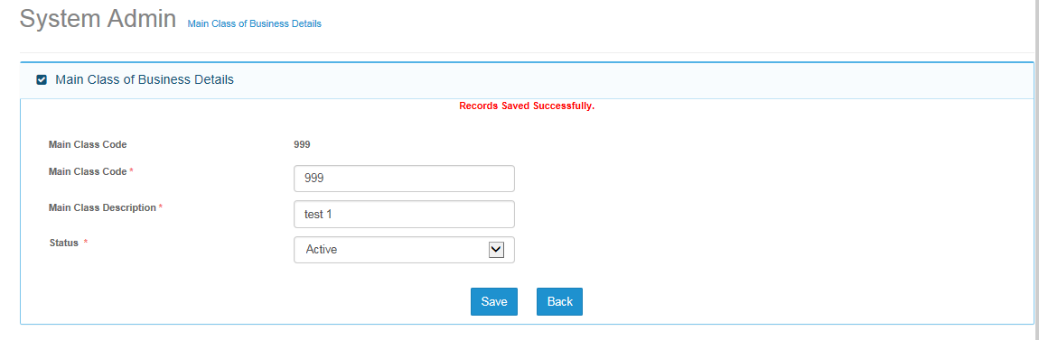

### Message Handling

* If user enters any existing main class code then below error message screen will appear.

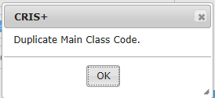

* If user click on save button without entering any values then below validation messages will appear.

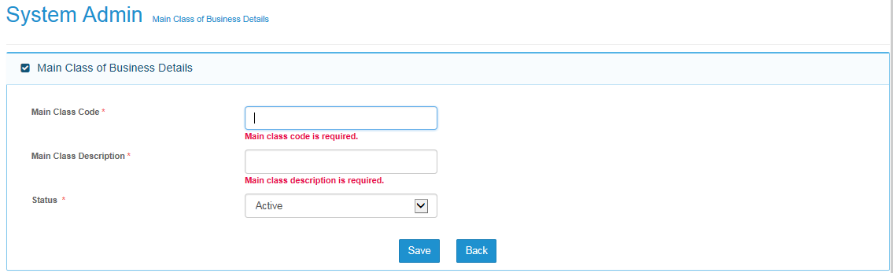

## Edit Screen

* Data elements of edit screen will saved as per add screen.
* User need to follow same validation as per add screen.

# Sub-Class

## Search Screen

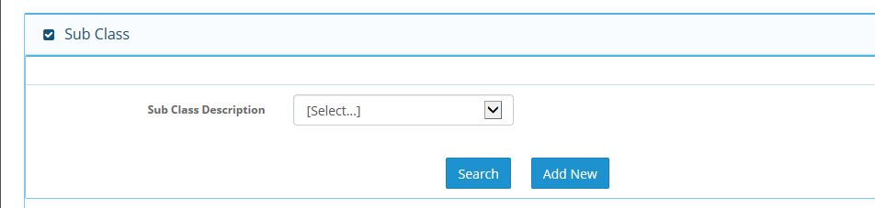

### Description

* Sub class search screen will be used to search record based on description selected by user from drop down list.

### Field Validations

|  |  |  |
| --- | --- | --- |
| **S.No.** | **Field Name** | **Validation** |
| 1. | Sub Class Description | Drop down list should have values already saved in the Application |

### Dependencies

* Not Applicable.

### Outcome

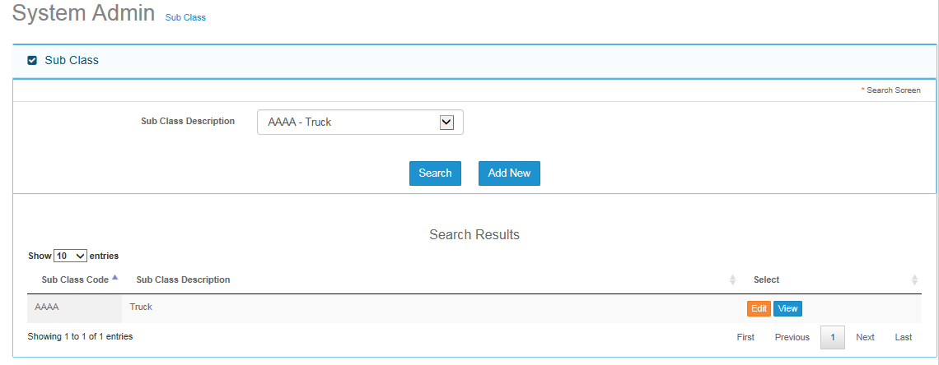

## Add Screen

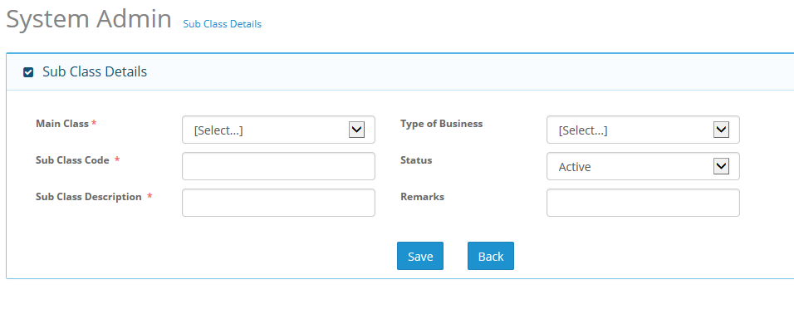

### Description

* Please add business wise functional information of sub-class master menu.

### Field Validations

|  |  |  |
| --- | --- | --- |
| **S.No.** | **Field Name** | **Validation** |
| 1. | Main Class | Drop down list, records must come from main class master |
| 2. | Sub Class Code | Length - 50 Character |
| 3. | Sub Class Description | Length -100 Character |
| 4. | Type of Business | Drop down list |
| 5. | Status | Drop Down List |
| 6. | Remarks | Length - 300 Character |

### Dependencies

* Add screen is dependent on main class master screen.

### Outcome

* Search result will come as per selection of record from drop down list.

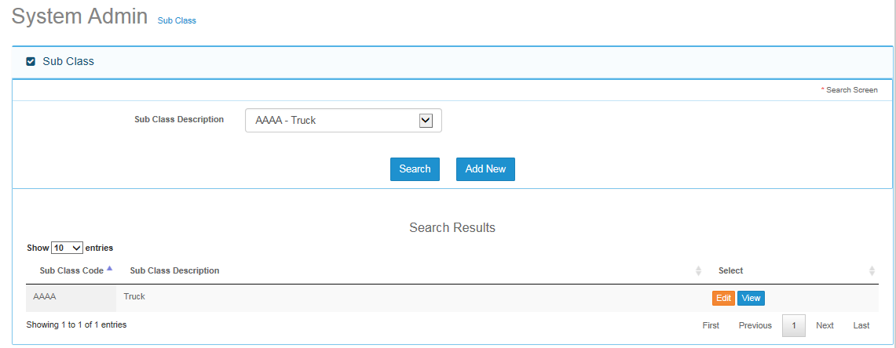

## Edit Screen

* Edit screen is having same data elements as per add screen.
* User can change selected record by clicking on edit button on search results screen.

# Claim expense master

* Please provide functional information of claim expense master.

## Search Screen

### 

### Field Validations

|  |  |  |
| --- | --- | --- |
| **S.No.** | **Field Name** | **Validation** |
| 1. | Claim Expense Master | Drop list must have already created values of claim expense master. |

### Outcome

* Based on selected record from claims expense Description, user will see result in search results section after clicking on search button.

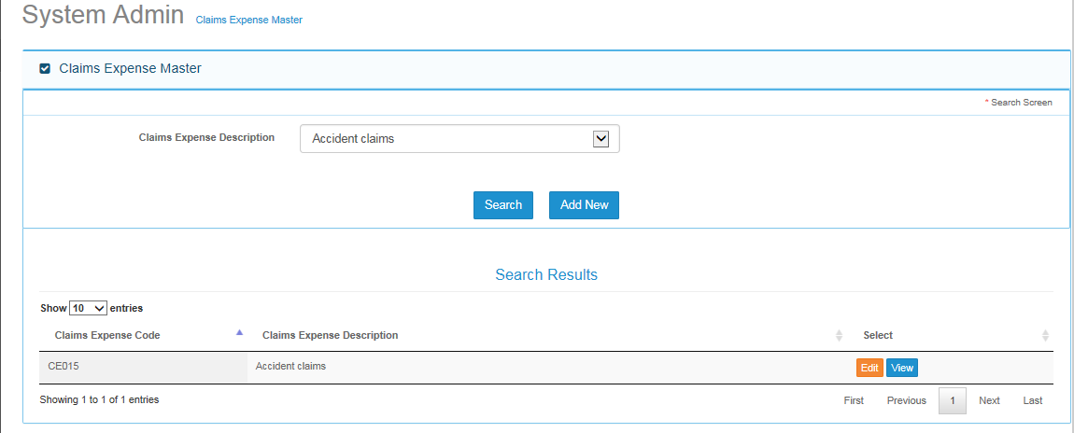

## Add Screen

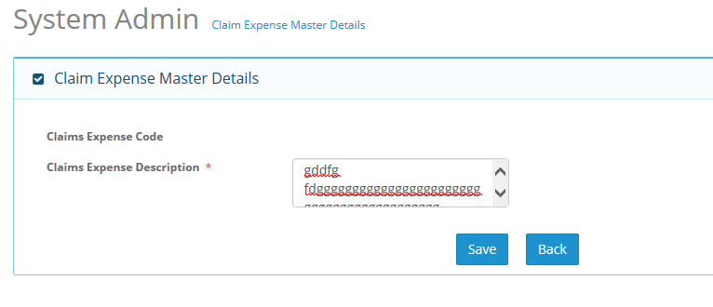

### Field Validations

|  |  |  |
| --- | --- | --- |
| **S.No.** | **Field Name** | **Validation** |
| 1. | Claim Expense Code | Not Applicable/Auto generated |
| 2. | Claim Expense Description | Length - 50 character |

### Dependencies

* NA

### Outcome

* Record will be saved in database and will appear in search result section.

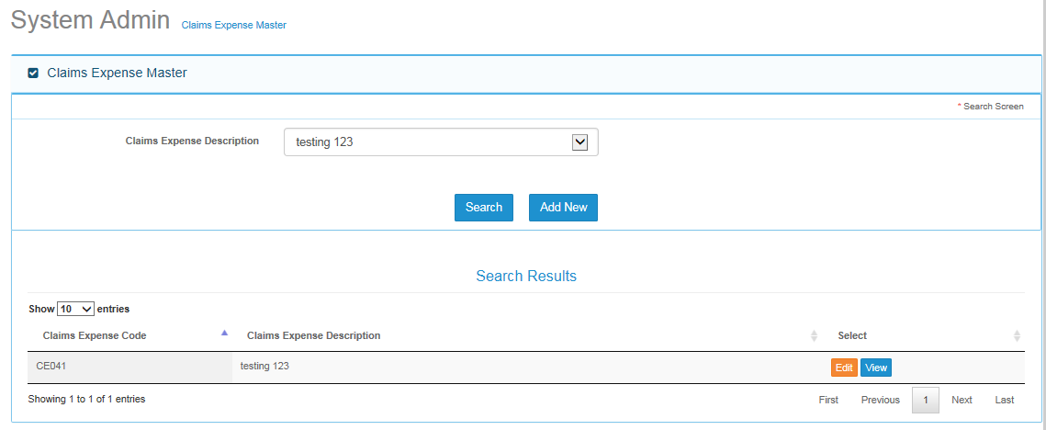

### Message Handling

* If user will click on save button before entering any value in claims expense description field, validation value appear as mentioned in below snap shot.

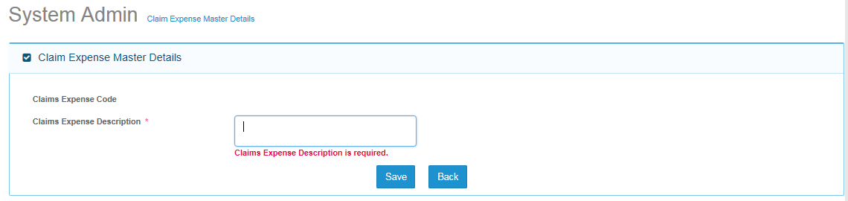

## Edit Screen

* Edit screen will be used to edit any existing record.
* Validation are same as per add screen.

# Claim Close Reason Master

## Search Screen

* User can search record by entering text in claims close reason description field.
* Input field is having smart search functionality , The moment user start typing in the box, application will start searching and displaying values starting from entered character ( please see below snap shot ).

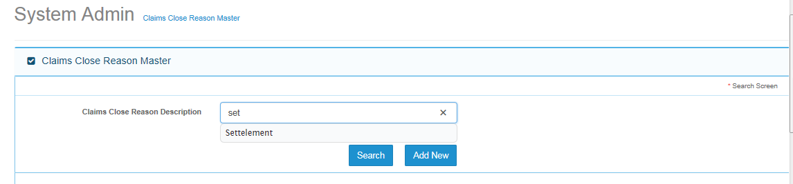

### Field Validations

|  |  |  |
| --- | --- | --- |
| **S. No.** | **Field Name** | **Validation** |
| 1. | Claim Close Reason Description | Infinite length |

### Dependencies

* Not Applicable

### Outcome

* Application will display search result as per entered text in the search criteria field.

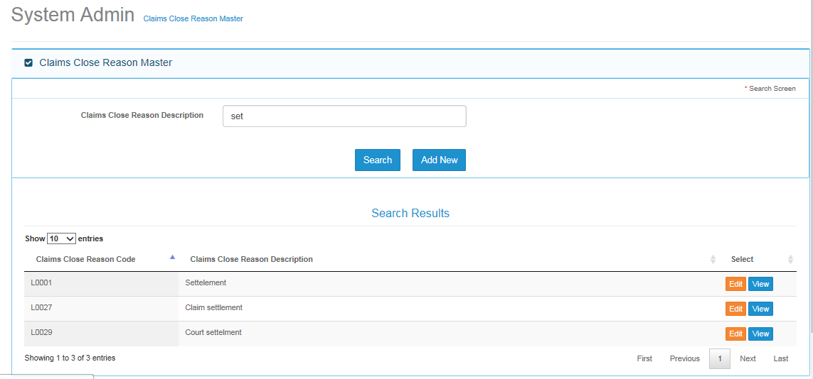

## Add Screen

### Field Validations

|  |  |  |
| --- | --- | --- |
| **S. No.** | **Field Name** | **Validation** |
| 1. | Claim Close Reason Code | Not Applicable/Auto generated |
| 2. | Claim Close Reason Description | Length - 450 character |

### Dependencies

* Not Applicable.

### Outcome

* Record will be saved and will start appearing in search result section of search screen.

### Message Handling

* Below validation error will come if user click on save button without entering any information.

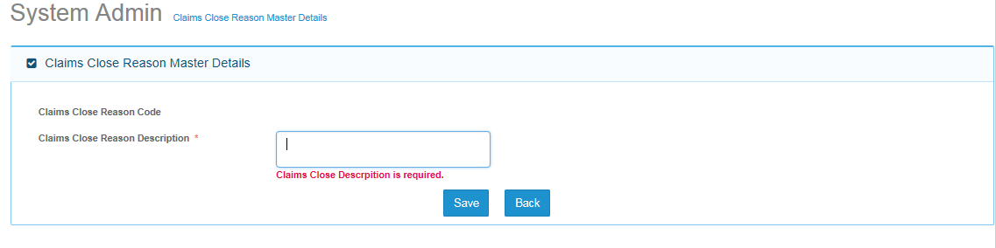

## Edit Screen

* Edit screen is having same validation as per add screen.
* Edited record will reflect in search result section..

# Currency Master

## Search Screen

### Field Validations

|  |  |  |
| --- | --- | --- |
| **S. No.** | **Field Name** | **Validation** |
| 1. | Currency Code | Infinite Length |
| 2. | Currency Display Code | Infinite Length |
| 3. | Currency Description | Infinite Length |

### Dependencies

* Not Applicable.

### Outcome

* Record will appear in search result section as per entered criteria by user.
* Search criteria is not case sensitive.

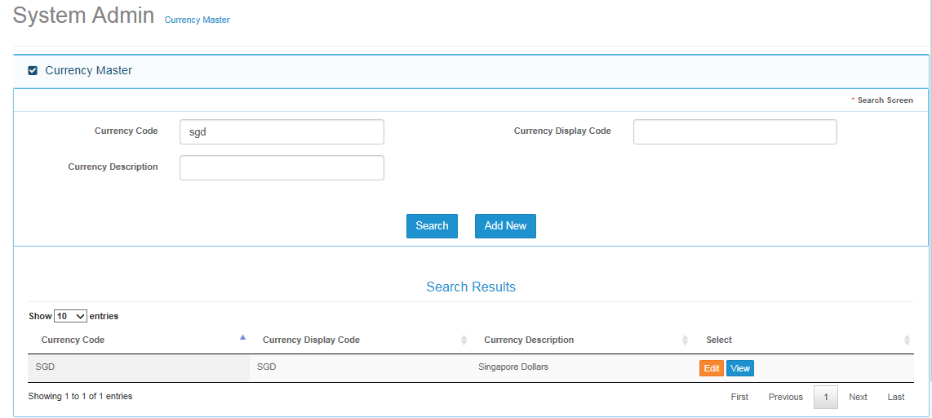

### Message Handling

* Not Applicable.

## Add Screen

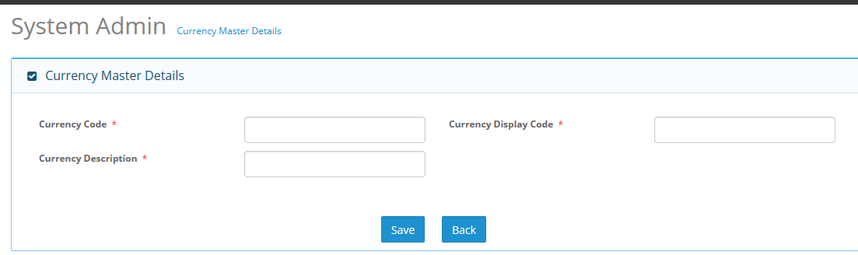

### Field Validations

|  |  |  |
| --- | --- | --- |
| **S. No.** | **Field Name** | **Validation** |
| 1. | Currency Code | Length - 4 characters |
| 2. | Currency Display Code | Length - 8 characters |
| 3. | Currency Description | Length - 25 characters |

* All fields having “*” sign is mandatory and must be filled before clicking on save button.

### Dependencies

* Not applicable.

### Outcome

* Record will save and start appearing in search result section.

### Message Handling

* Below mention validation message will come if user press on save button without entering values.

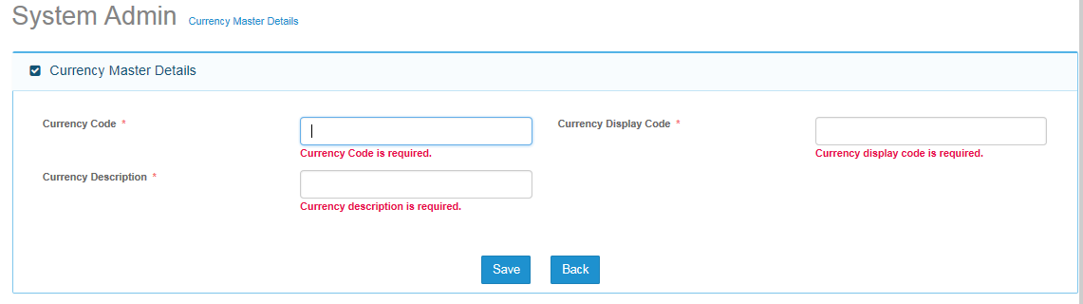

## Edit Screen

* Edit screen is having same validation and dependencies as per add screen.
* Edited record will reflect in search result section.

# Exchange Rate Master

## Search Screen

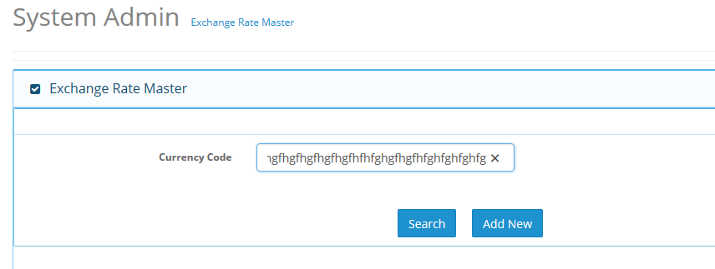

### Field Validations

|  |  |  |
| --- | --- | --- |
| **S. No.** | **Field Name** | **Validation** |
| 1. | Currency Code | Max Length |

### Dependencies

* Not Applicable.

### Outcome

* Search result section will show results

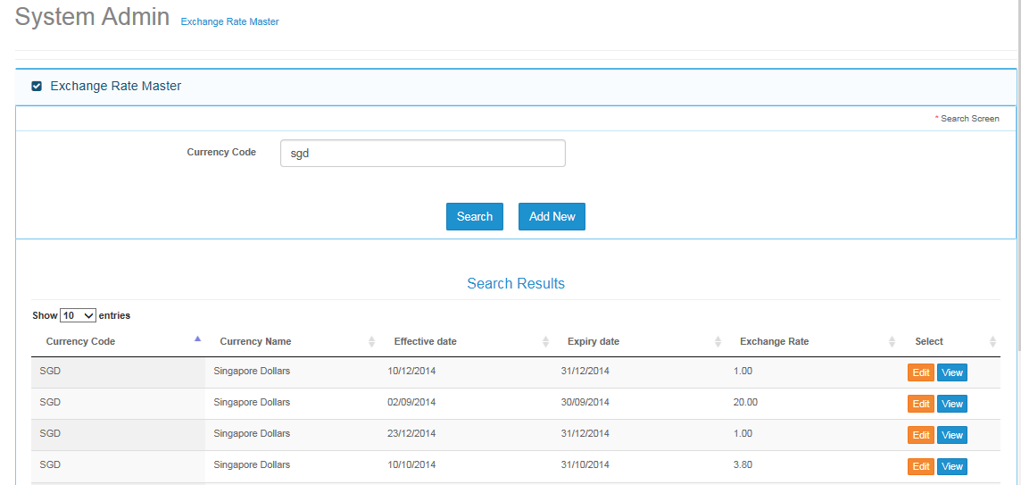

## Add Screen

### Field Validations

|  |  |  |
| --- | --- | --- |
| **S. No.** | **Field Name** | **Validation** |
| 1. | Currency Code | Length - 4 characters |
| 2. | Currency Effective Date | Length - Date field |
| 3. | Exchange Rate | Length - 11 characters |

### Dependencies

* Currency master must be created before saving exchange rate.

### Outcome

* After clicking on save button, save message will appear.
* Saved record will start appearing in search result section.

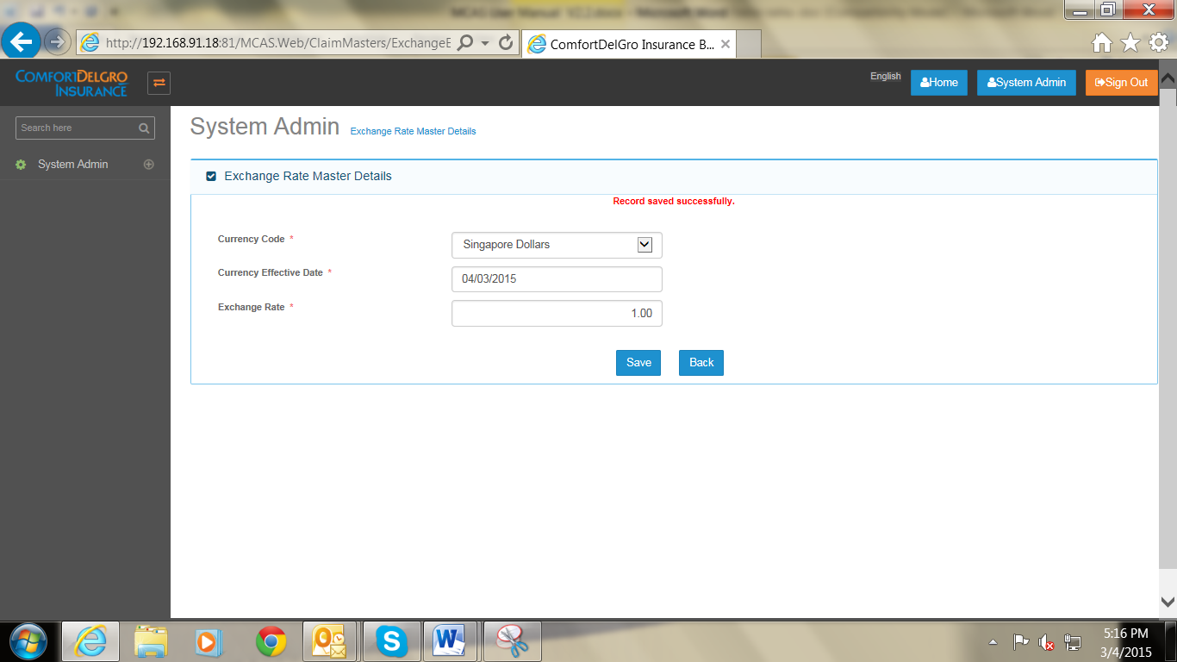

### Message Handling

* If user tries to create two exchange rate on same currency in a day system will prompt error message.

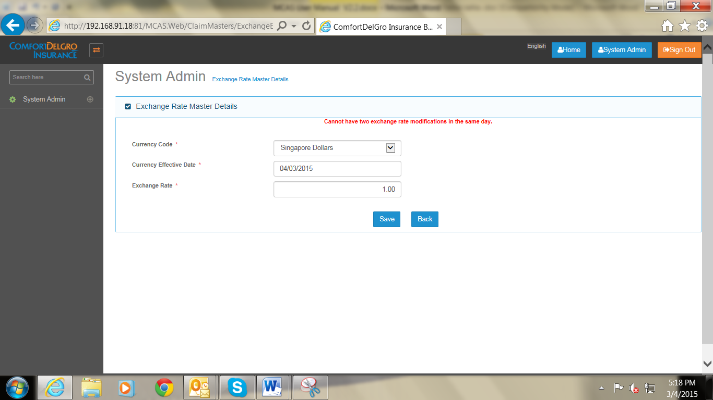

## Edit Screen

* User need to select current date to edit exchange rate of previously saved exchange rate.

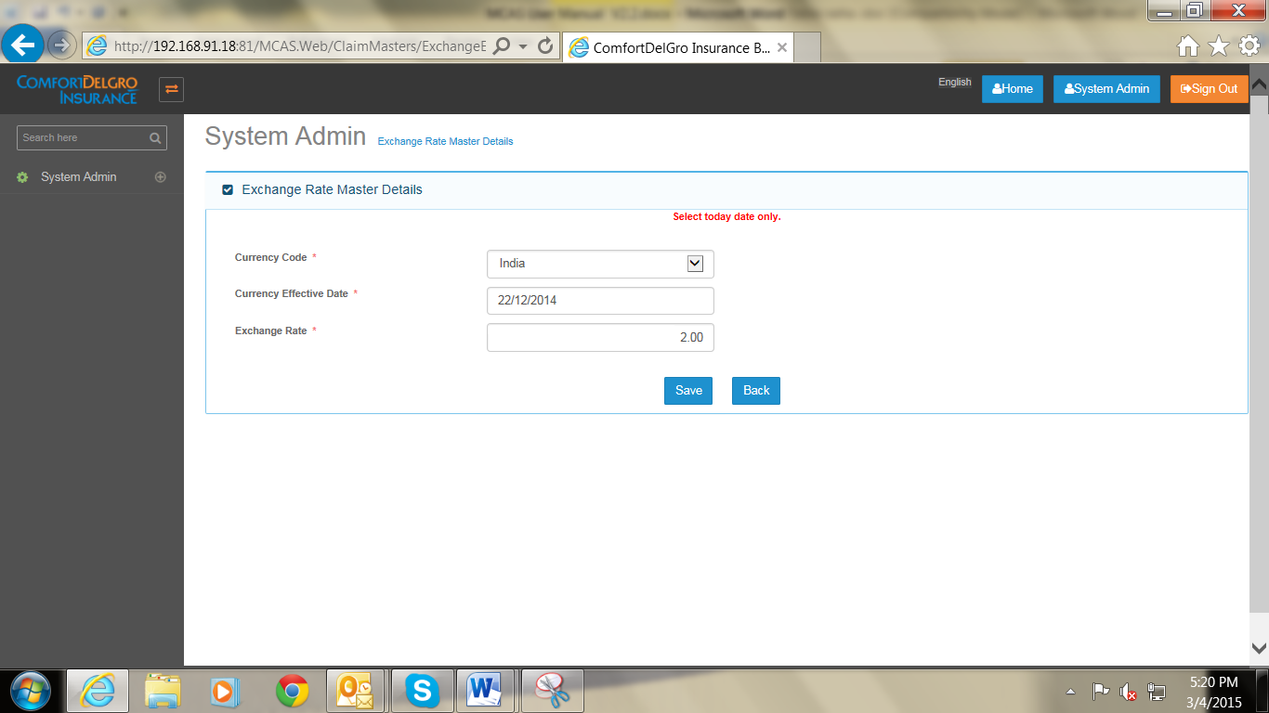

# User Admin

## Entity Details

### Search Screen

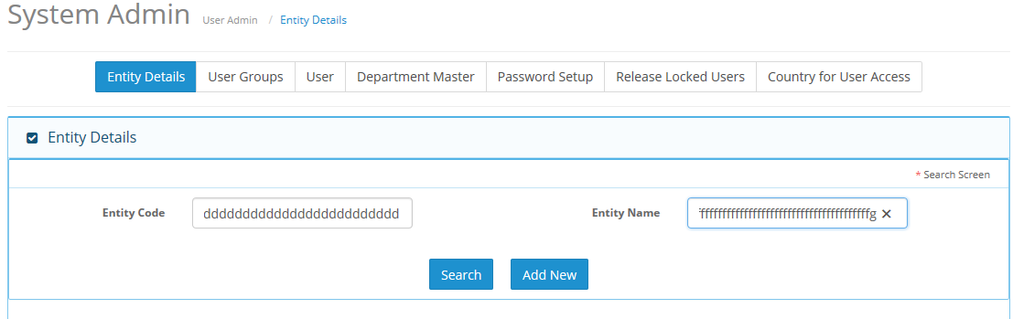

#### Field Validations

|  |  |  |
| --- | --- | --- |
| **S. No.** | **Field Name** | **Validation** |
| 1. | Entity Code | Max Length |
| 2. | Entity Name | Max Length |

#### Dependencies

* Not Applicable.

#### Outcome

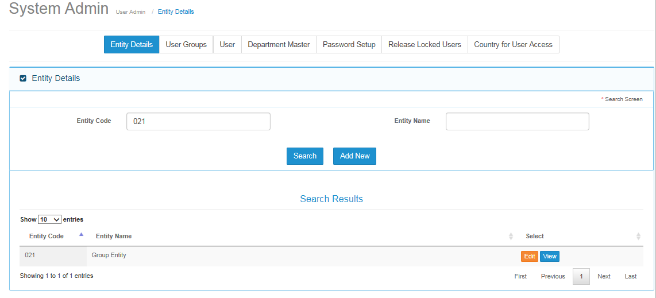

#### Message Handling

* Not Applicable.

### Add Screen

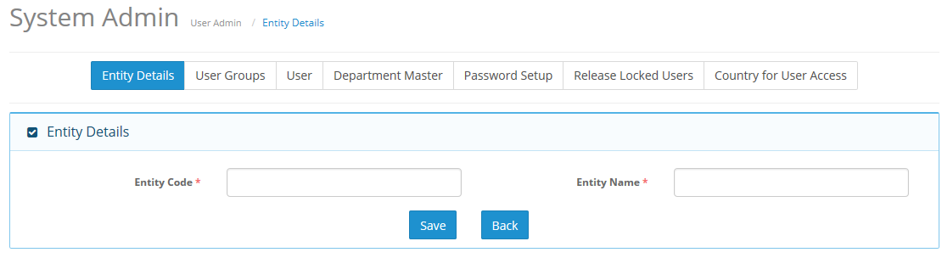

#### Field Validations

|  |  |  |
| --- | --- | --- |
| **S. No.** | **Field Name** | **Validation** |
| 1. | Entity Code | Length – 3 |
| 2. | Entity Name | Length - 30 |

#### Dependencies

* Not Applicable.

#### Outcome

* Record will be saved and will start appearing in search result.

#### Message Handling

* For blank mandatory fields , Error message will appear as per mentioned in below snap shot.

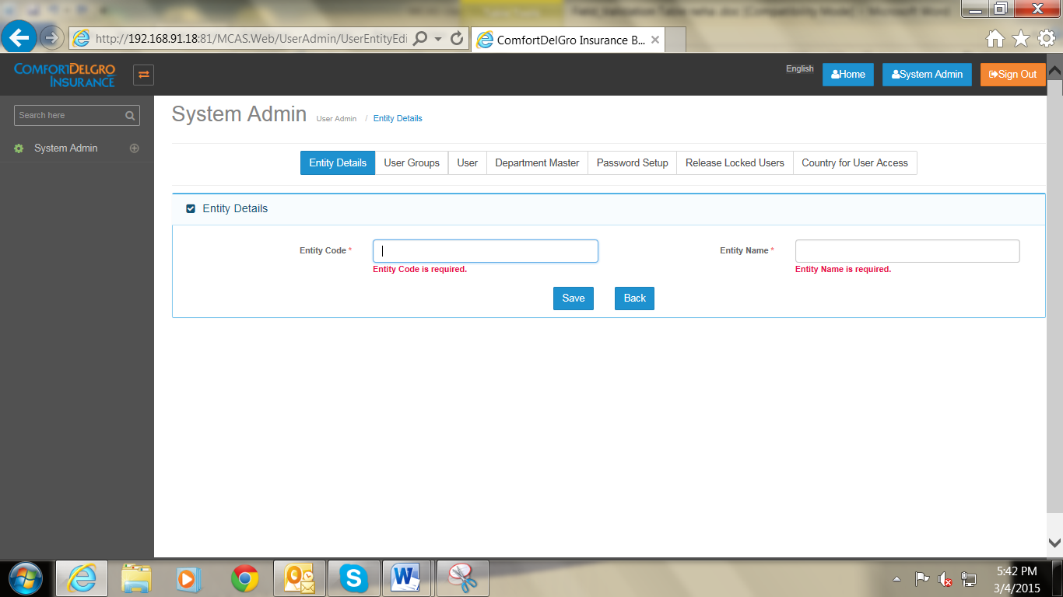

### Edit Screen

* Edit Screen will have same validation/Dependencies as per add screen.

## User Group

* Application is having below mentioned functionality for managing users
  + Group Master ( Permission Assigned to groups )
    - User Master ( Group Assigned to individual user )
      * Organization assigned to users

### Search Screen

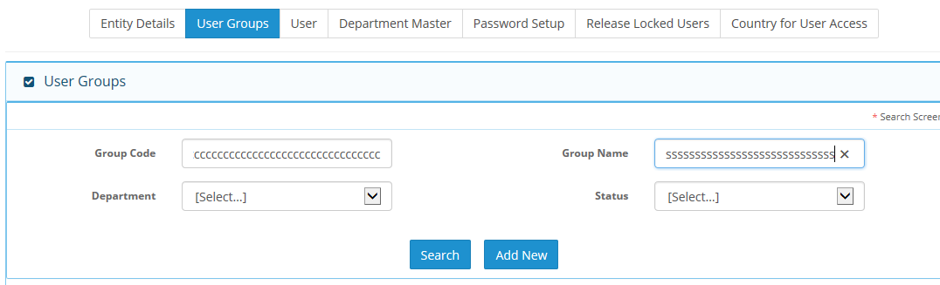

#### Field Validations

|  |  |  |
| --- | --- | --- |
| **S. No.** | **Field Name** | **Validation** |
| 1. | Group Code | Max Length |
| 2. | Group Name | Max Length |
| 3. | Department | Drop down list |
| 4. | Status | Active / Inactive |

#### Dependencies

* Department master must be created first before saving user group master.

#### Outcome

* Search record will appear in search result section.

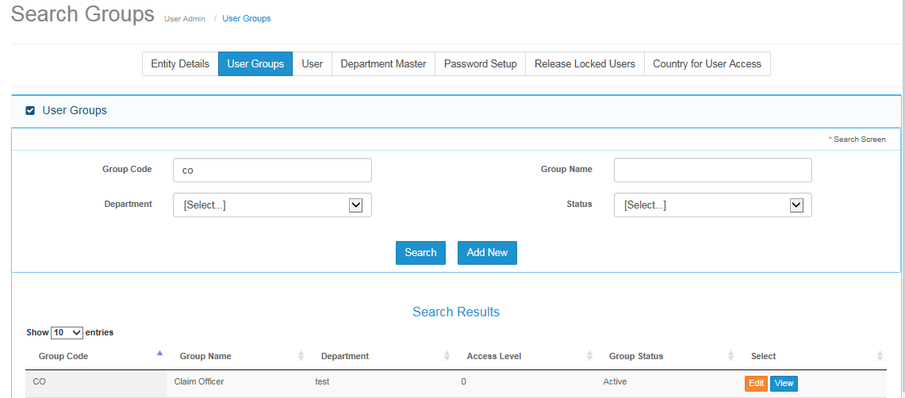

* Below screen will appear If user any value which does not exist .

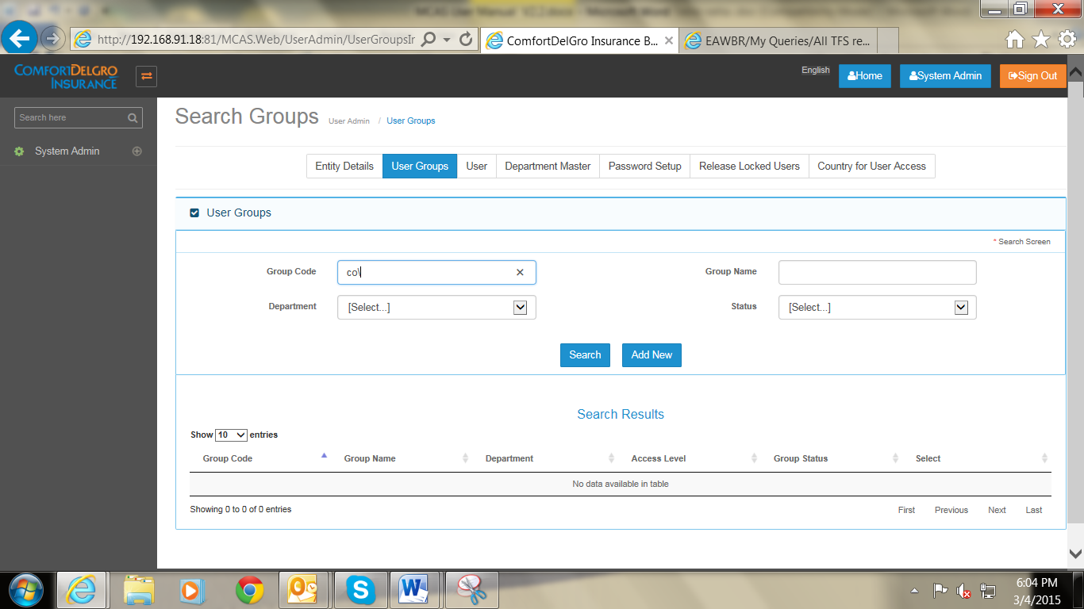

### Add Screen

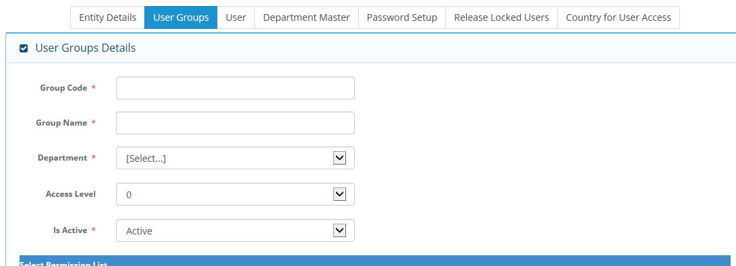

#### Field Validations

|  |  |  |
| --- | --- | --- |
| **S. No.** | **Field Name** | **Validation** |
| 1. | Group Code | 2 characters |
| 2. | Group Name | 50 characters |
| 3. | Department | Not applicable |
| 4. | Access Level | Not applicable |
| 5 | Is Active | Not applicable |

#### Dependencies

* Department master must be created first.

#### Outcome

* Record will be saved and will start appearing in search result section.

#### Message Handling

* Below validation error message will appear if user click on save button without inserting any values in mandatory field.
* 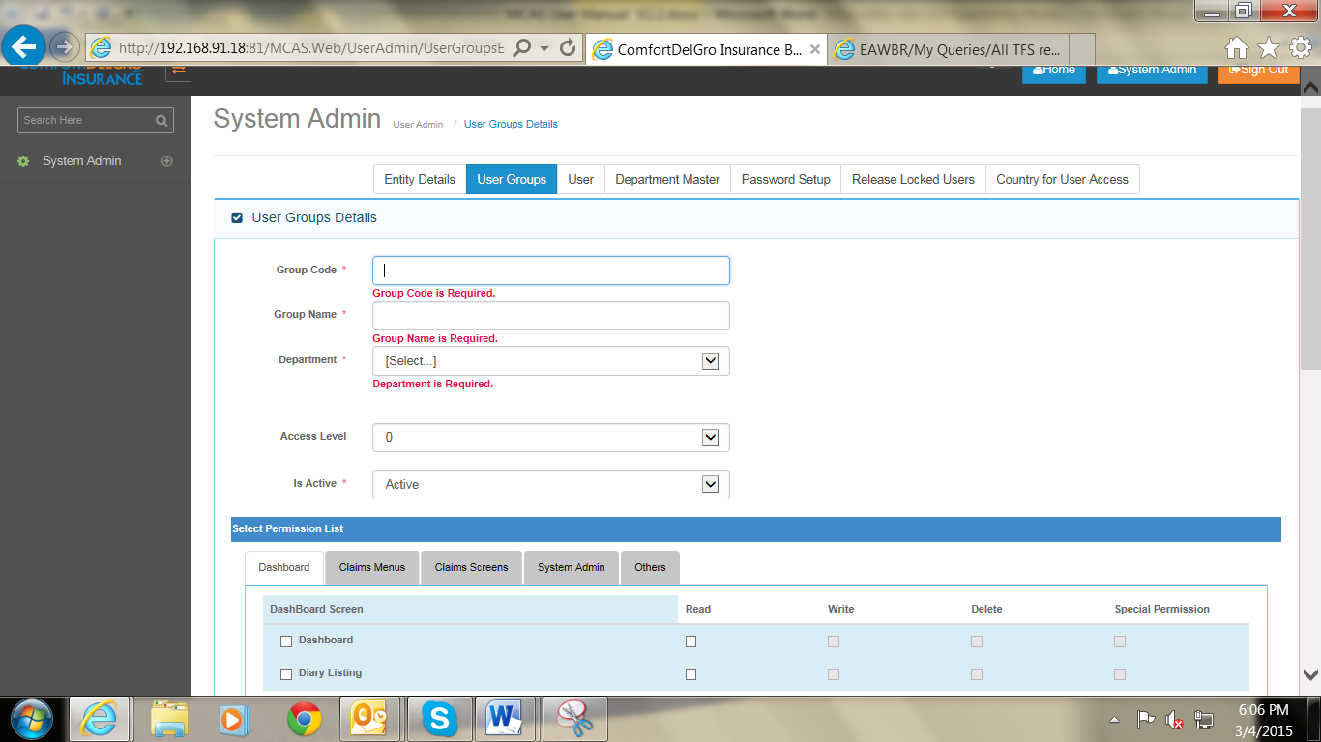

### Edit Screen

* Edit screen is having same validation and dependencies as per add screen.
* Edited record will be reflected in search result with updated details.

### Select Permission List Screen

* Permission list is having 5 tabs
  + Dashboard – screen/Menu names related to dashboard will appear in this tab.
  + Claims Menus – Menu names of claim registration module will appear in this tab.
  + Claims screens - Screens which comes under claims registration module will appear in this tab.
  + System Admin – All master screens names will appear in this tab.
  + Others – Any special security related screen will appear in this tab ( ex: Attachement type folder options)
* Application is having below mentioned permissions
  + Read –User can view the screen/menu.
  + Write - User can add data in the screen/menu. ( Add button will appear in related screen)
  + Delete – user can delete data in the screen / Menu ( delete button will appear in related screen )
  + Special permission – If other read / write / Delete permission / control comes then application will map that control in special permission. ( example diary reassignment button view when , special permission is checked on diary screen.)

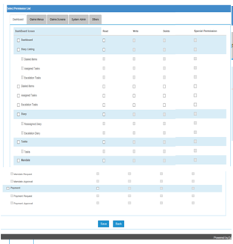

* Screen for other 5 tabs will appear like above mentioned screen shot.
* All tab screen will functionally work as per below mentioned field validations

#### Field Validations

* When head check box is clicked then all other check boxes will automatically checked.
* By Default write / delete and special permission check box will be read only.
* After check of read check box only, write/ delete and special permission boxes will be checked.
* If a menu is having multiple sub menus, then on click of head check box other menu and sub menu related check boxes will be automatically checked.

#### Outcome

* As per permission assigned to a particular user group, Screens and menus will appear

## User Screen

### Search Screen

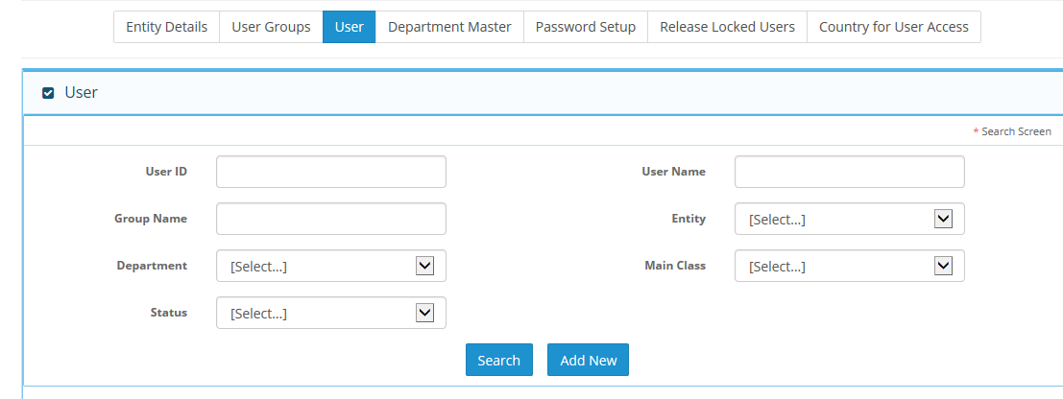

#### Field Validations

|  |  |  |
| --- | --- | --- |
| **S. No.** | **Field Name** | **Validation** |
| 1. | User ID | Max Length |
| 2. | Group Name | Max Length |
| 3. | Department | Not applicable |
| 4. | Status | Not applicable |
| 5 | User Name | Max Length |
| 6. | Entity | Not applicable |
| 7. | Main Class | Not applicable |

#### Dependencies

* Department Master
* Main Class
* Status : Active / Inactive

#### Outcome

* As per entered search criteria result will appear in search result section.

### Add Screen

#### Field Validations

|  |  |  |
| --- | --- | --- |
| **S. No.** | **Field Name** | **Validation** |
| 1. | User ID | Length - 7 |
| 2. | User Full Name | Length - 50 |
| 3. | Password | Max Length |
| 4. | Confirm Password | Max Length |
| 5 | User Display Name | 50 |
| 6. | Department | Drop Down List |
| 7. | Entity | Drop Down List |
| 8. | Email | Max Length |
| 9. | Group | Drop Down List |
| 10. | Country | Drop Down List |
| 11. | Payment Limit | 11 characters |
| 12. | Credit Note Limit | 11 character |
| 13. | Active | Active/Inactive |
| 14. | User Access | Drop Down List |

#### Dependencies

* Department master
* Entity master
* Group master
* Country master

#### Outcome

* User will be created and display in the search result section.
* User will be able to login from newly created user id, password.

#### Message Handling

* Below mention error message will come when user presses save button without entering values in mandatory field.

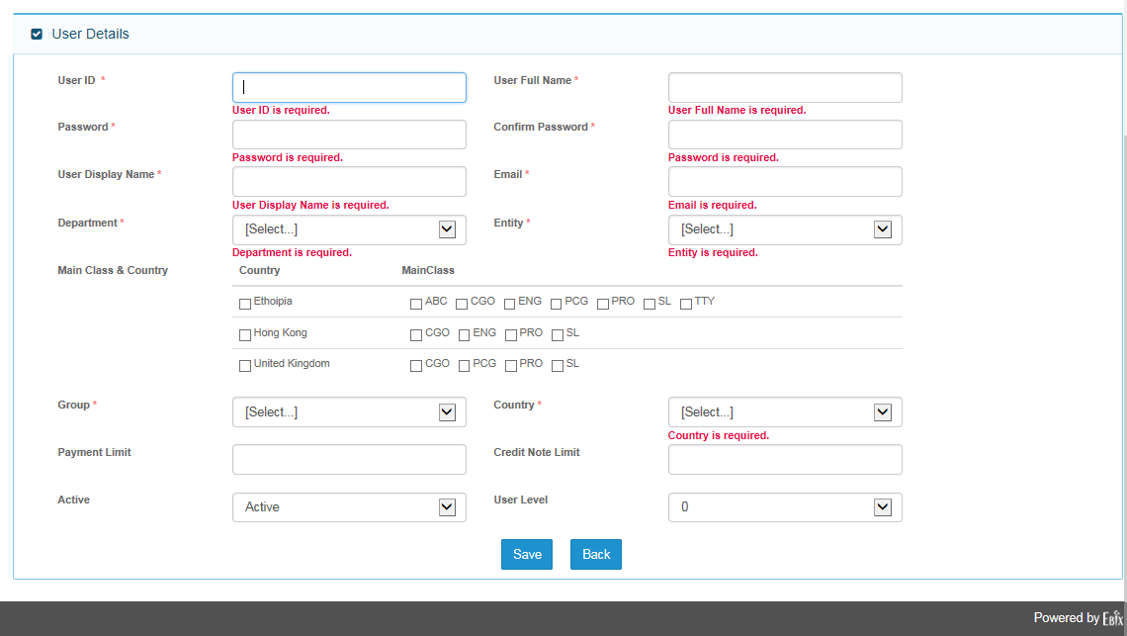

### Edit Screen

* Editing an existing user is having similar dependencies and validation as per add user screen.
* User will see organization Access tab when click on edit screen.

### Organization Access Tab

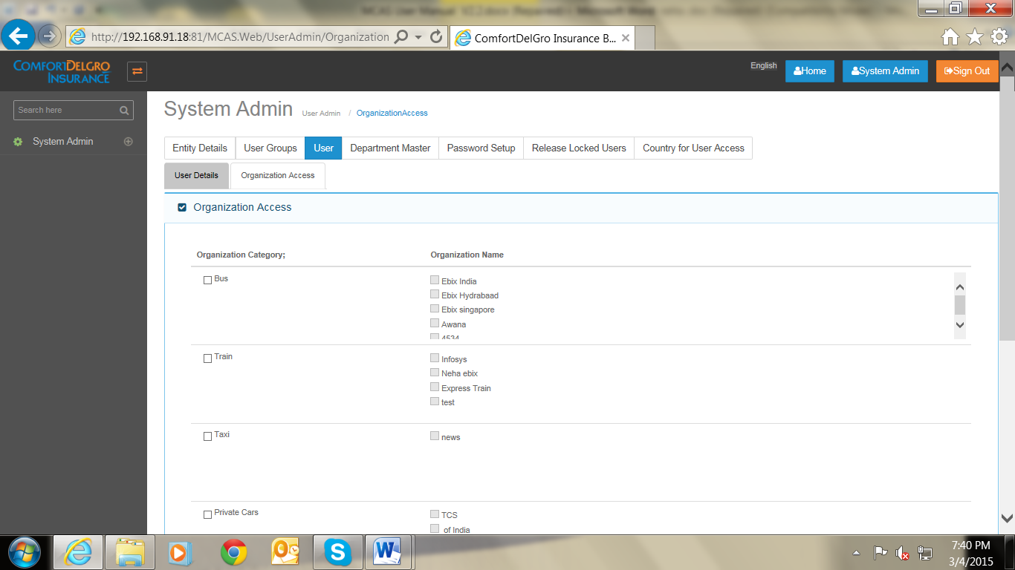

#### Field Validations

* Country will be first assigned to user, on user details tab screen.
* Organization which is related to assigned country to user will appear in organization access screen.

#### Dependencies

* Country master
* Organization names are dependent on organization category.

#### Outcome

* Selected organization from organization access tab screen will appear on accident screen -> organization drop down list.

### FAL Access to User

* Under Development.

#### Description

#### Field Validations

#### Dependencies

#### Outcome

#### Message Handling

## Department master

### Search Screen

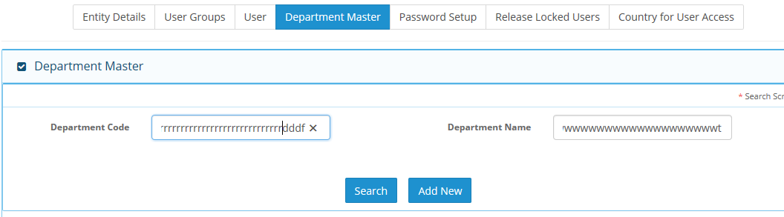

#### Field Validations

|  |  |  |
| --- | --- | --- |
| **S. No.** | **Field Name** | **Validation** |
| 1. | Department Code | Max Length |
| 2. | Department Name | Max Length |

#### Dependencies

* Not applicable.

#### Outcome

* Based on search criteria user will see records on search results section.

### Add Screen

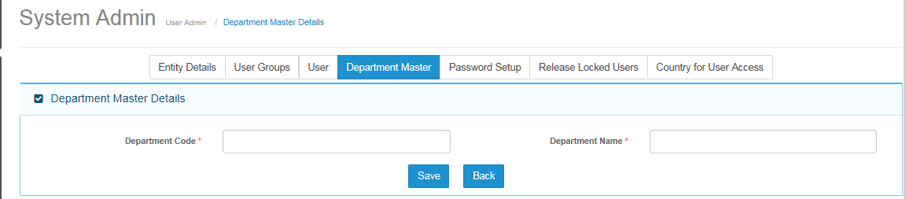

#### Field Validations

|  |  |  |
| --- | --- | --- |
| **S. No.** | **Field Name** | **Validation** |
| 1. | Department Code | 10 |
| 2. | Department Name | 50 |

#### Dependencies

* Not applicable.

#### Outcome

* Record will start appearing on search result section

### Edit Screen

* Validations are same as per add department screen.

## Password Setup

### Main Screen

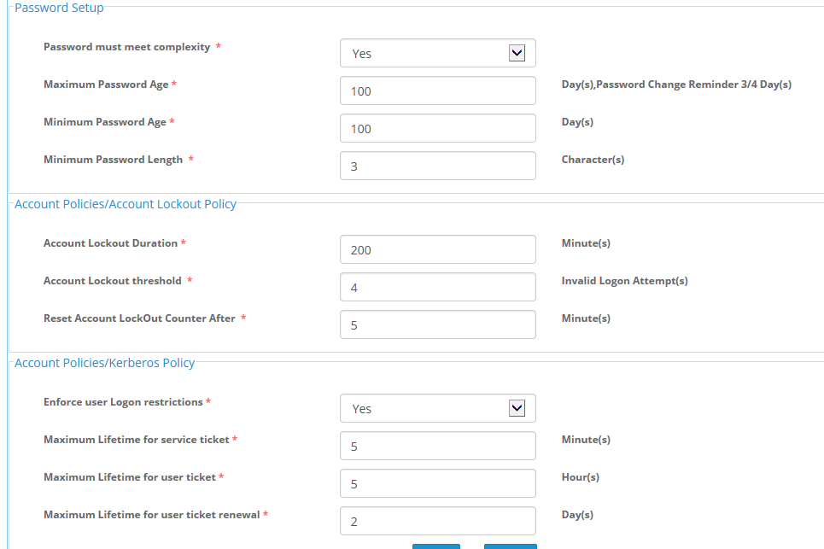

#### Field Validations

* Not known.

|  |  |  |
| --- | --- | --- |
| **S. No.** | **Field Name** | **Validation** |
| 1. | Password must meet complexity | Not applicable |
| 2. | Maximum Password Age | 3 Numeric Characters |
| 3. | Minimum Password Age | 3 Numeric Characters |
| 4. | Minimum Password Length | 3 Numeric Characters |
| 5 | Account Lockout Duration | 3 Numeric Characters |
| 6. | Account Lockout threshold | 3 Numeric Characters |
| 7. | Reset Account Lock Out Counter After | 3 Numeric Characters |
| 8. | Enforce user Log on restrictions | Not applicable |
| 9. | Maximum Lifetime for service ticket3 Numeric Characters | 3 Numeric Characters |
| 10. | Maximum Lifetime for user ticket | 3 Numeric Characters |
| 11. | Maximum Lifetime for user ticket renewal | 3 Numeric Characters |

#### Dependencies

* Not Applicable.

#### Outcome

#### Message Handling

## Released Locked User

* Requirement Pending

## Country For User Access

* Requirement Pending

# Country Master

## Search Screen

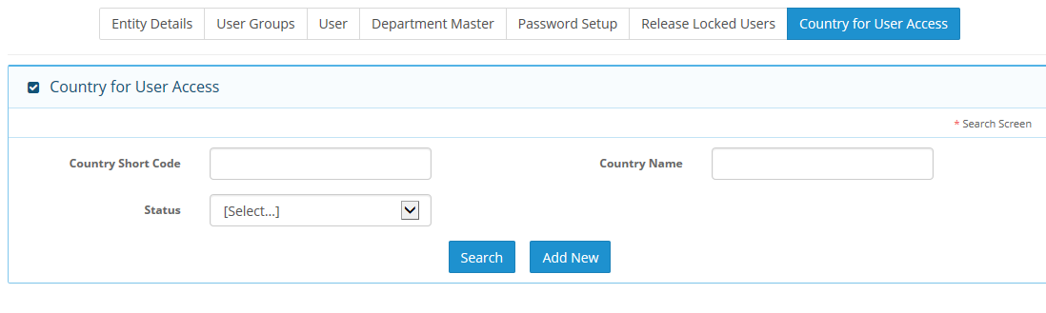

### Field Validations

|  |  |  |
| --- | --- | --- |
| **S. No.** | **Field Name** | **Validation** |
| 1. | Country Short Code | Max Length |
| 2. | Country Name | Max Length |
| 3. | Status | Active/Inactive |

### Dependencies

* Not Applicable.

### Outcome

* As per search criteria entered user will see output in search results.

## Add Screen

### 

### Field Validations

|  |  |  |
| --- | --- | --- |
| **S. No.** | **Field Name** | **Validation** |
| 1. | Country Short Code | System generated code |
| 2. | Country Name | Drop down list |
| 3. | Status | Active / Inactive |

### Dependencies

* Not Applicable.

### Outcome

* Selected country will be active and will start appearing in the system drop down list.

## Edit Screen

* User can Edit country name and provide country short code
* After editing any record it will start appearing on search result section.

# Vehicle Class

## Search Screen

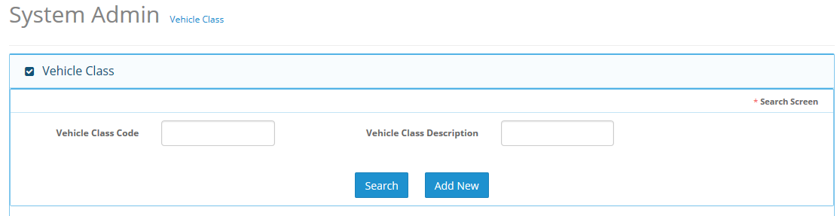

### Field Validations

|  |  |  |
| --- | --- | --- |
| **S. No.** | **Field Name** | **Validation** |
| 1. | Vehicle Class Code | Max Length |
| 2. | Vehicle Class Description | Max Length |

## Add Screen

### Field Validations

|  |  |  |
| --- | --- | --- |
| **S. No.** | **Field Name** | **Validation** |
| 1. | Vehicle Class Code | Max Length |
| 2. | Vehicle Class Description | Max Length |

# Vehicle Make

## Search Screen

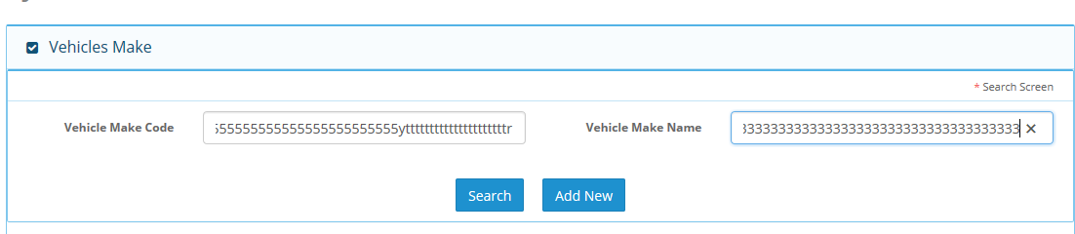

### Field Validations

|  |  |  |
| --- | --- | --- |
| **S. No.** | **Field Name** | **Validation** |
| 1. | Vehicle Make Code | Max Length |
| 2. | Vehicle Make Name | Max Length |

### Dependencies

* Not Applicable.

## Add Screen

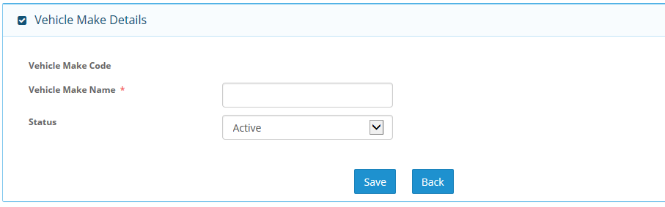

### Field Validations

|  |  |  |
| --- | --- | --- |
| **S. No.** | **Field Name** | **Validation** |
| 1. | Vehicle Make name | 100 alphanumeric characters |
| 2. | Status | Not Applicable |
| 3. | Vehicle make code | Auto generated 6 alphanumeric characters |

## Edit Screen

* Validations are same as per add screen.
* Edited record will start appearing in search results.

# Vehicle Model

## Search Screen

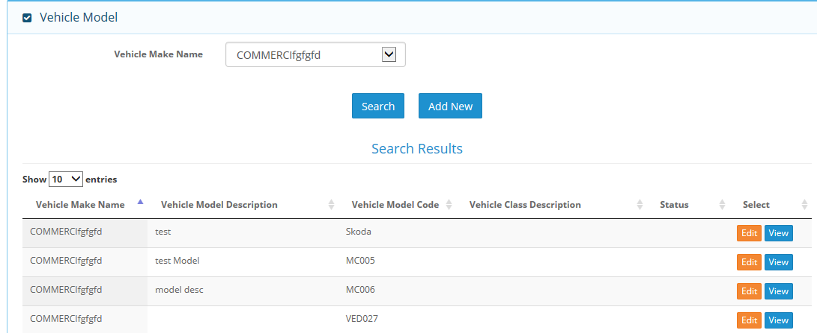

### Field Validations

|  |  |  |
| --- | --- | --- |
| **S. No.** | **Field Name** | **Validation** |
| 1. | Vehicle Model Name | Not Applicable |

## Add Screen

### Field Validations

|  |  |  |
| --- | --- | --- |
| **S. No.** | **Field Name** | **Validation** |
| 1. | Vehicle Model Code | Not Applicable |
| 2. | Vehicle Make Name | Not Applicable |
| 3. | Model Description |  |
| 4. | Vehicle Class description | Not Applicable |
| 5. | Cylinder Capacity |  |
| 6. | Tonnage |  |
| 7. | No. of Passenger |  |
| 8. | status | Not Applicable |

### Dependencies

* Vehicle class master

## Edit Screen

* Validation and dependency of edit screen is same as per add screen of vehicle model.

# Insurance Policy

## Search Screen

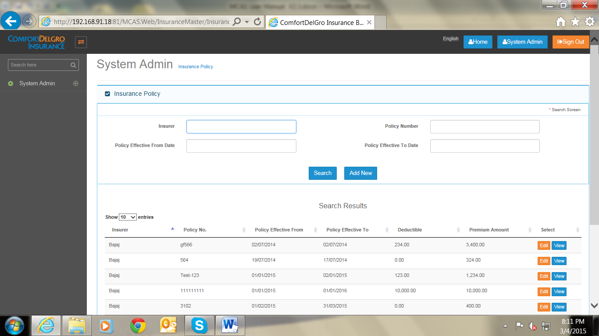

### Field Validations

|  |  |  |
| --- | --- | --- |
| **S. No.** | **Field Name** | **Validation** |
| 1. | Insurer | Max Length |
| 2. | Policy Number | Max Length |
| 3. | Policy Effective From Date | Date Field |
| 4, | Policy Effective To Date | Date Field |
|  |  |  |

### Dependencies

* Not applicable.

### Outcome

* Record will display in search result option.

## Add Screen

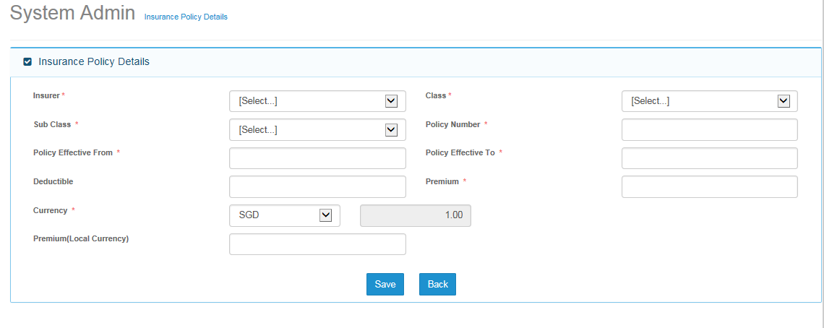

### Field Validations

|  |  |  |
| --- | --- | --- |
| **S. No.** | **Field Name** | **Validation** |
| 1. | Insurer | Drop Down List |
| 2. | Class | Drop Down List |
| 3. | Sub class | Drop Down List |
| 4, | Policy Number | Ma x length - 45 |
| 5 | Policy Effective From Date | Date Field |
| 6 | Policy Effective To Date | Date Field |
| 7 | Deductible | Numeric field, Length – 11 |
| 8 | Premium | Numeric field, Length – 11 |
| 9 | Currency | Drop down list |
| 10 | Exchange rate | Based on currency |
| 11 | Premium local currency | Numeric field, Length – 11,Decimal - 2 |

### Dependencies

* Insurer
* Class
* Sub class
* Currency
* Exchange Rate

## Edit Screen

* Validation and dependency are same as per add screen .

# GST Setting

## Search Screen

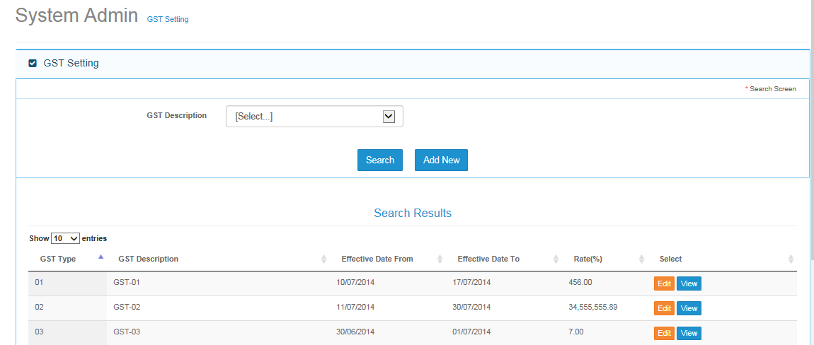

### Field Validations

* Not Applicable.

### Dependencies

* Not applicable.

### Outcome

### Message Handling

## Add Screen

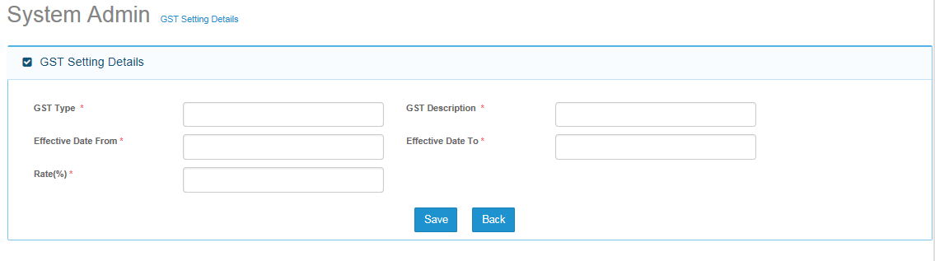

### Field Validations

### Dependencies

### Outcome

### Message Handling

# Organization

## Search Screen

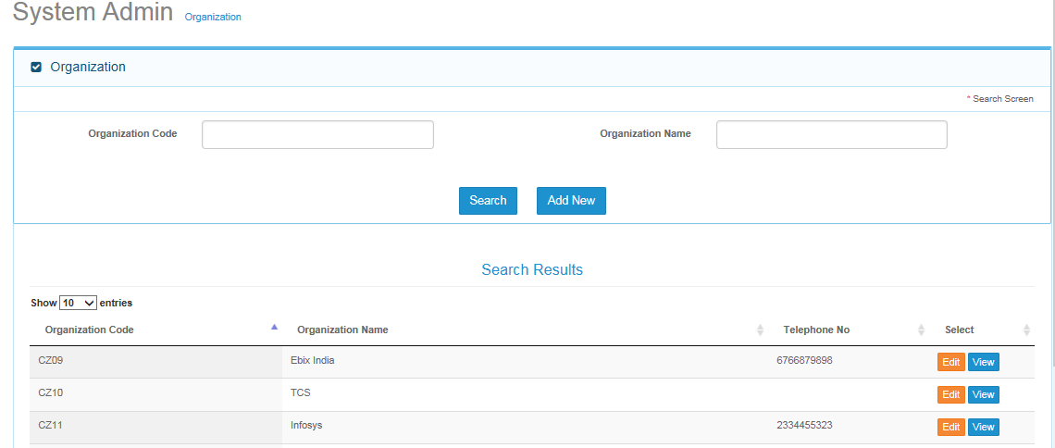

### Outcome

* Record will appear in search result section.

## Add Screen

### Description

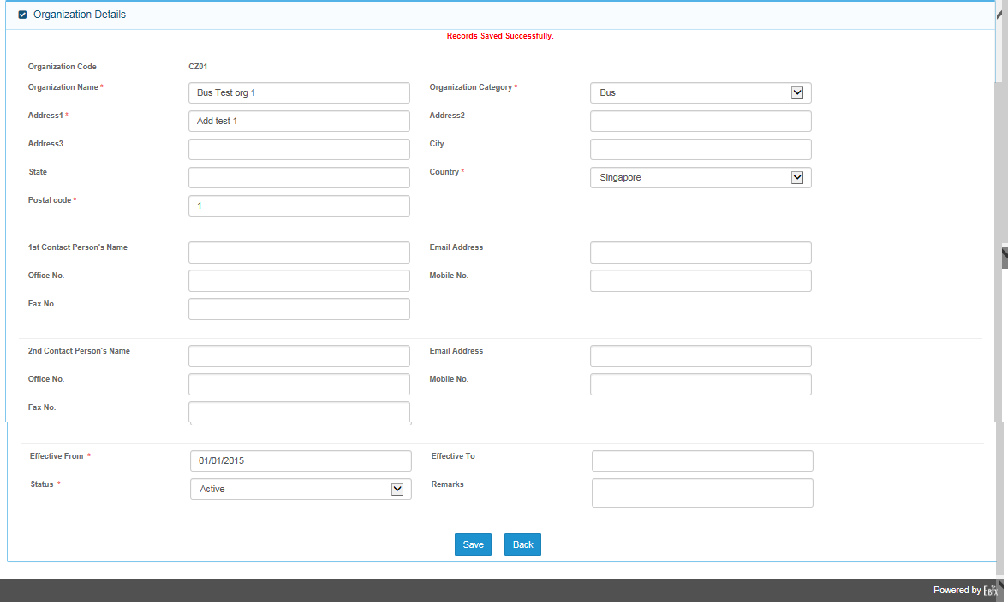

### Field Validations

|  |  |
| --- | --- |
| **Field Name**  Organization Name | **Input Type** |
| Organization Category | Alphanumeric  Drop down List | |
| Address1 | Alphanumeric | | |
| Address2 | Alphanumeric | | |
| Address3 | Alphanumeric | | |
| City | Alphanumeric | | |
| State | Alphanumeric | | |
| Country | Alphanumeric | | |
| Postal Code | Numeric | | |
| 1st Contact Person’s Name | Alphanumeric | | |
| Email Address | Alphanumeric | | |
| Office No. | Numeric | | |
| Mobile No. | Numeric | | |
| Fax No. | Numeric | | |
| 2nd Contact Person’s Name | Alphanumeric | | |
| Email Address | Alphanumeric | | |
| Office No. | Numeric | | |
| Mobile No. | Numeric | | |
| Fax No. | Numeric | | |
| Effective From | Date | | |
| Effective To | Date | | |
| Status | Alphanumeric | | |
| Remarks | Alphanumeric | | |
| Year Rating Issued | Alphanumeric | | |
|  |

### Dependencies

* Country Master

### Outcome

### Message Handling

## Edit Screen

* Validation are same as per add screen.

# Claim Officer Duty

## Search Screen

### Description

### Field Validations

### Dependencies

### Outcome

### Message Handling

## Add Screen

### Description

### Field Validations

### Dependencies

### Outcome

### Message Handling

## Edit Screen

### Description

### Field Validations

### Dependencies

### Outcome

### Message Handling

# LOU Rate

## Search Screen

### Description

### Field Validations

### Dependencies

### Outcome

### Message Handling

## Add Screen

### Description

### Field Validations

### Dependencies

### Outcome

### Message Handling

## Edit Screen

### Description

### Field Validations

### Dependencies

### Outcome

### Message Handling

# Service Provider Master

## Insurer Master

## Search Screen

#### Description

#### Field Validations

#### Dependencies

#### Outcome

#### Message Handling

## Add Screen

#### Description

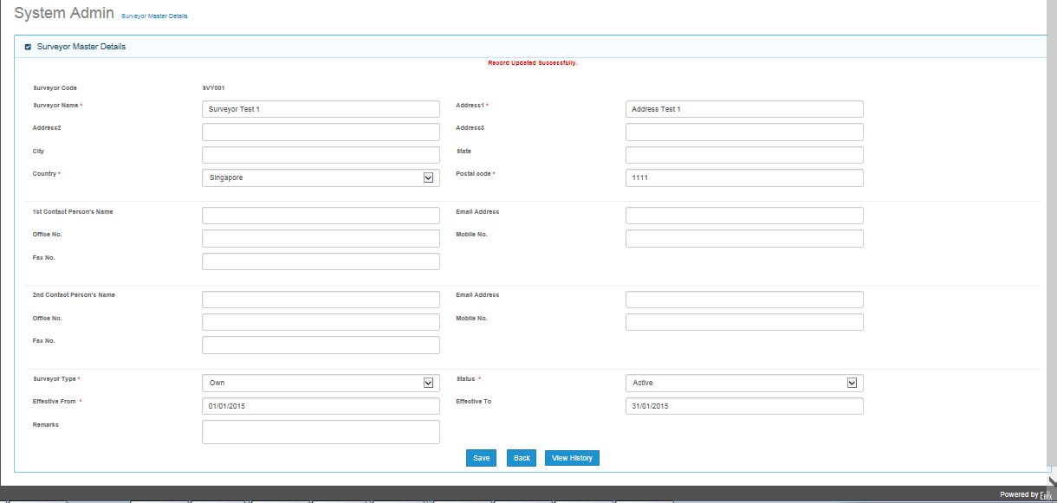

#### Field Validations

#### Dependencies

#### Outcome

#### Message Handling

## Edit Screen

#### Description

#### Field Validations

#### Dependencies

#### Outcome

#### Message Handling

## Surveyor Master

## Search Screen

#### Description

#### Field Validations

#### Dependencies

#### Outcome

#### Message Handling

## Add Screen

#### Description

#### Field Validations

#### Dependencies

#### Outcome

#### Message Handling

### Edit Screen

#### Description

#### Field Validations

#### Dependencies

#### Outcome

#### Message Handling

## Lawyer Master Screen

## Search Screen

#### Description

#### Field Validations

#### Dependencies

#### Outcome

#### Message Handling

## Add Screen

#### Description

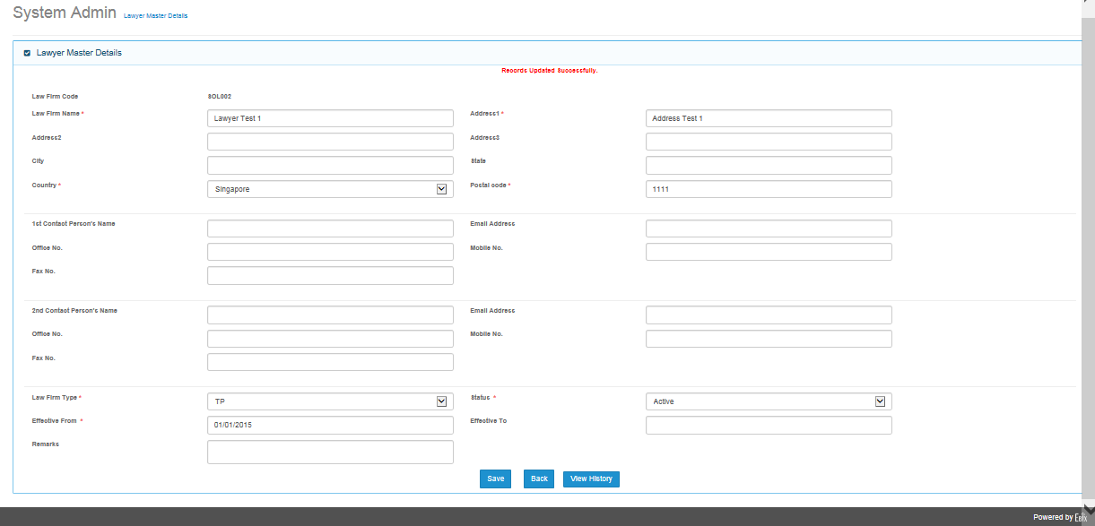

#### Field Validations

#### Dependencies

#### Outcome

#### Message Handling

## Edit Screen

#### Description

#### Field Validations

#### Dependencies

#### Outcome

#### Message Handling

## Workshop/Depot Master

## Search Screen

#### Description

#### Field Validations

#### Dependencies

#### Outcome

#### Message Handling

## Add Screen

#### Description

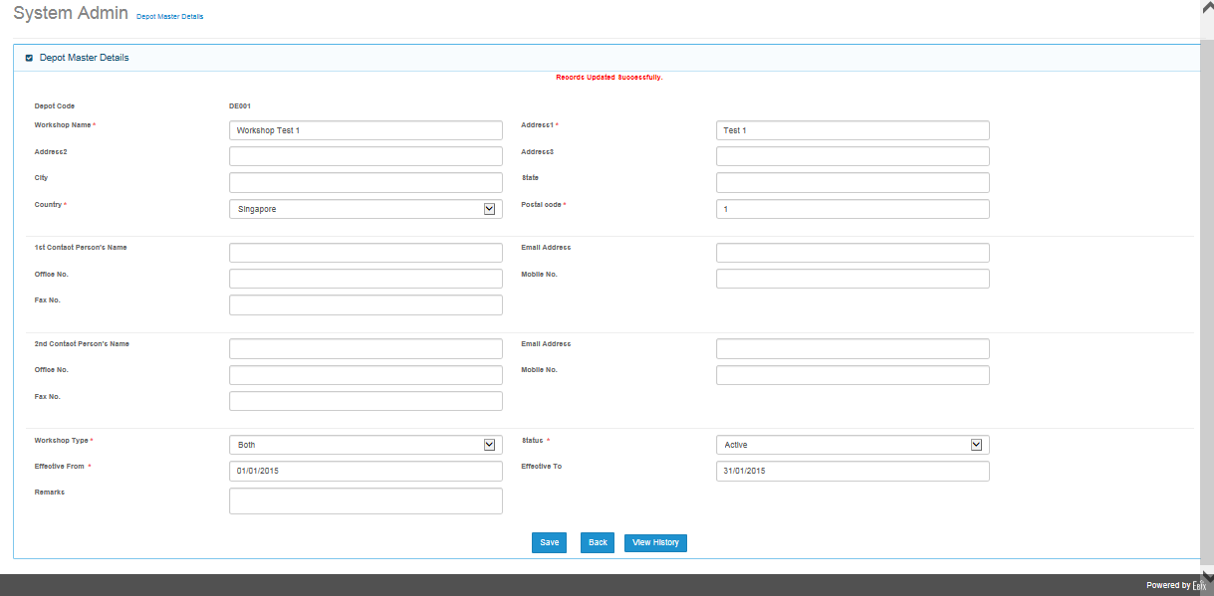

#### Field Validations

#### Dependencies

#### Outcome

#### Message Handling

## Edit Screen

#### Description

#### Field Validations

#### Dependencies

#### Outcome

#### Message Handling

## Hospital Master

## Search Screen

#### Description

#### Field Validations

#### Dependencies

#### Outcome

#### Message Handling

## Add Screen

#### Description

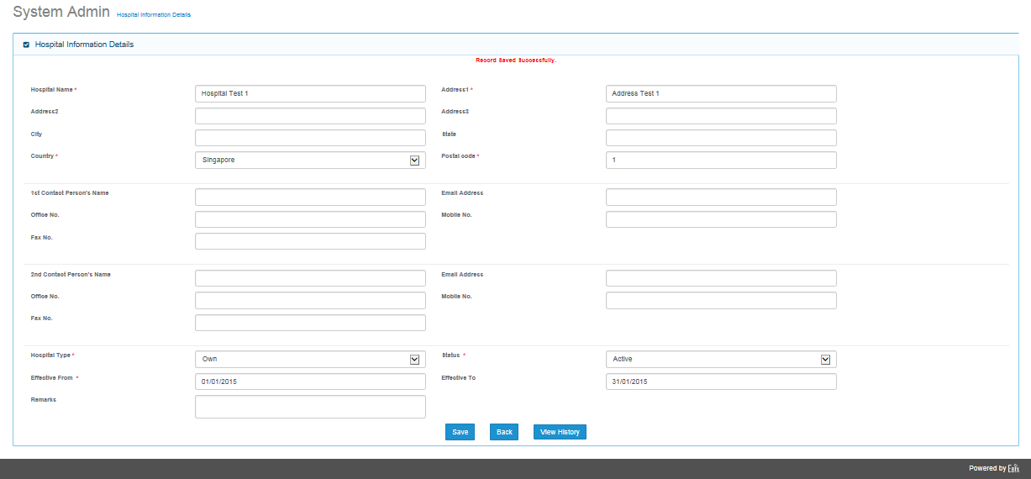

#### Field Validations

#### Dependencies

#### Outcome

#### Message Handling

## Edit Screen

#### Description

#### Field Validations

#### Dependencies

#### Outcome

#### Message Handling

## Adjuster Master

## Search Screen

#### Description

#### Field Validations

#### Dependencies

#### Outcome

#### Message Handling

## Add Screen

#### Description

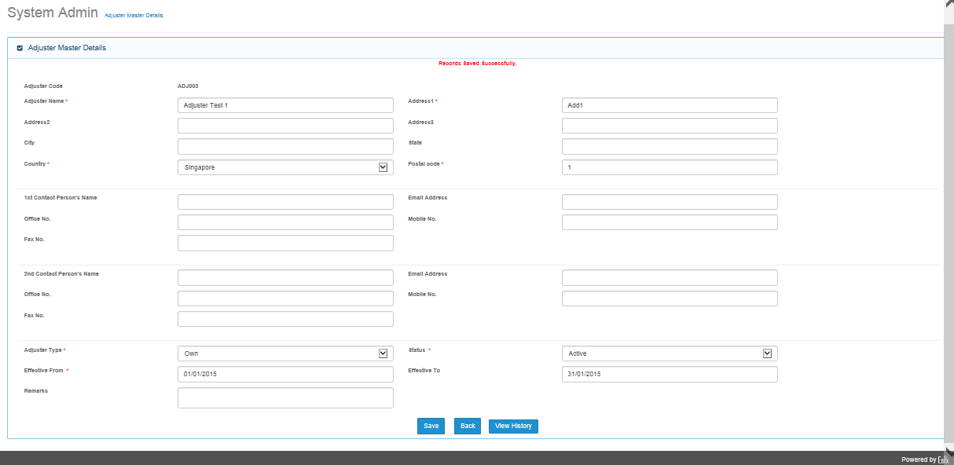

#### Field Validations

#### Dependencies

#### Outcome

#### Message Handling

## Edit Screen

#### Description

#### Field Validations

#### Dependencies

#### Outcome

#### Message Handling

# Interchange Master Screen

## Search Screen

### Description

### Field Validations

### Dependencies

### Outcome

### Message Handling

## Add Screen

### Description

### Field Validations

### Dependencies

### Outcome

### Message Handling

## Edit Screen

### Description

### Field Validations

### Dependencies

### Outcome

### Message Handling

# Deductible Master

## Search Screen

### Description

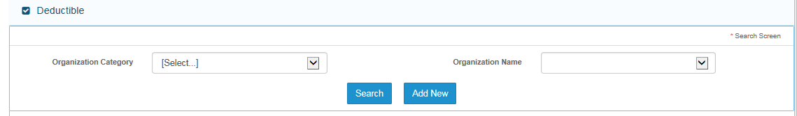

### Field Validations

|  |  |  |
| --- | --- | --- |
| S..no. | Field name | Validation |
| 1 | Organization Category | Drop down list , not applicable |
| 2 | Organization Name | Drop Down List, Not Applicable |

### Dependencies

### Outcome

### Message Handling

## Add Screen

### Description

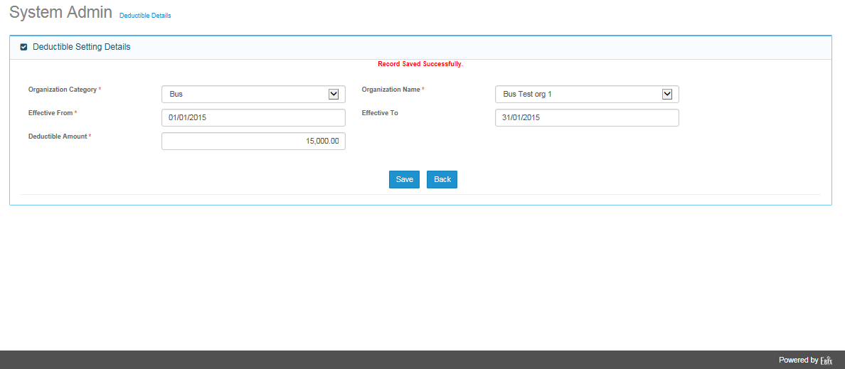

### Field Validations

### Dependencies

### Outcome

### Message Handling

## Edit Screen

### Description

### Field Validations

### Dependencies

### Outcome

### Message Handling